Kyushu Institute of Technology

Department of Applied Science for Integrated System Engineering





**BIRDS-X Project**

**DRAGONFLY**

**Battery Verification Test Report**

|  |  |  |  |
| --- | --- | --- | --- |
| **Date** | **Revision Number** | **Writer** | **Annotations** |
| 2024/03/24 | 1.0 | Zamba Leonel | Initial release |
| 2024/08/23 | 2.0 | Yudai Etsunaga | Applicable Documents Fixes |

**Table of Contents**

1. Purpose 3

2. Applicable Documentation 3

3. Design for the Battery and Hardware 3

**3.1** **Short Description of the Battery System** 3

**3.2** **Cell Description:** 3

**3.3** **Battery Description:** 4

4. Test Method 4

4.1 Acceptance Test 4

5. Test Results 6

6. Selected Batteries 43

7. Battery self-discharge measurement 43

8. Conclusion 47

# Purpose

This document summarizes the result of the battery verification test for BIRDS-X Satellite (DRAGONFLY) which will be deployed from JEM Small Satellites Orbital Deployer (J-SSOD-R).

# Applicable Documentation

1. **JX-ESPC-101132-E JEM Payload Accommodation Handbook Vol.8 Small**

**Satellite Deployment Interface Control Document**

1. **01_BIRDS-X-EP-01 HR Battery Description Form for BIRDS-X**
2. **16_DRAGONFLY-SAR-02 BIRDS-X Flight Safety Assessment Report for phase III**

# Design for the Battery and Hardware

* 1. **Short Description of the Battery System**

The battery cell is COTS. The cells are installed in a battery case. The electrodes are sealed with an insulator, and each cell is covered with a Kapton tape for insulation independently.

* 1. **Cell Description:**

Chemistry: Ni-MH

Size: φ14.35*50.4 mm

Manufacturer: Panasonic

Model number: BK-3MCC

Nominal open circuit voltage: 1.2 V

Rated capacity: 2,000 mAh

* 1. **Battery Description:**

Quantity of cells per battery: 6 cells

Cell connectivity (#P#S, #S#P): 3S2P

Operating voltage range: 3.6– 4.8 V

Operating temperature range: 0 to +40 deg C

Charge: 0 to +40 degC,

Discharge: 0 to +50 degC,

Storage: -20 to +40 degC

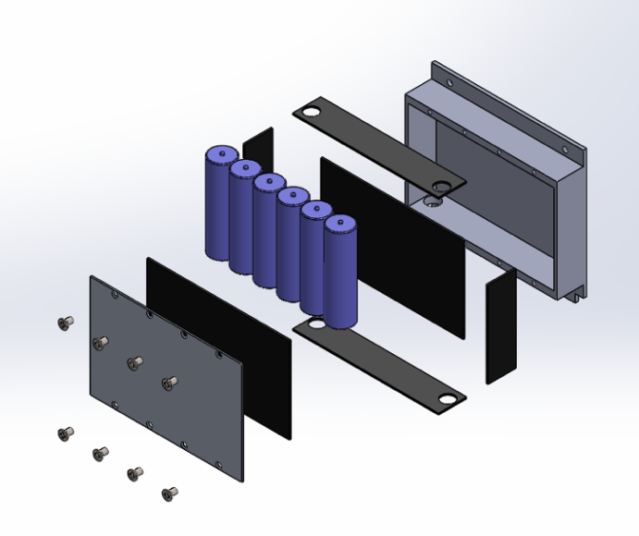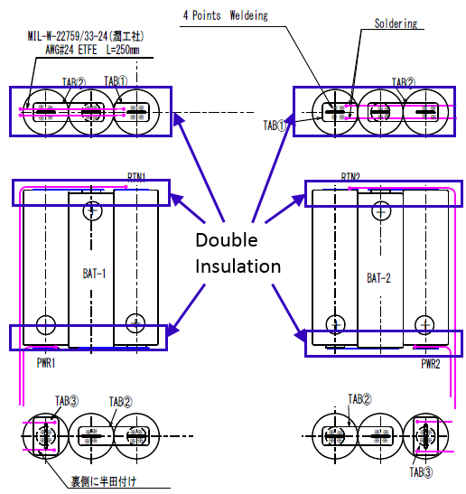

**Figure 3-1. Battery box and Connectivity**

# Test Method

The battery cells were purchased by COTS product. The battery cell itself is screened by environment test and function test.

## Acceptance Test

1. Random Vibration Test

Random vibration test for flight cells is performed for screening purpose.

Test condition is summarized as below.

Vibration Level: Minimum Screening Level (MSL)

Tolerance: +/- 1.5dB for PSD

Direction: 2 axes (Radial direction and Axial direction)

Test Duration: Over 60 sec

**Table 4.2-1 Random Vibration Level for cells**

|  |  |
| --- | --- |
| **Freq. [Hz]** | **PSD [G2/Hz] (MSL)** |
| 20 | 0.01 |
| 80 | 0.04 |
| 350 | 0.04 |
| 2000 | 0.007 |
| Overall | 6.06 Grms |
| Duration | 1. min/axis |

1. Vacuum Test

Vacuum test of battery cell level is performed for screening. test condition is summarized below.

Vacuum Level: less than 0.1 psia

Test Duration: Over 6 hours

1. Function Test

Before and after the environment tests (vibration test and vacuum test), several function tests below are performed to see that there is no change in characteristics.

Test Load: 2.0 [A]

Test Contents;

* Visual inspection (scratches, misaligned seals, electrolyte leakage etc.)
* Open Circuit Voltage (the change is less than 0.1%)
* Mass (the change is less than 0.1%)
* Capacity (the change is less than 5%)
* Charge/Discharge Characteristic
* Discharge Temperature

Charge and discharge characteristics tests are performed for each battery cells before and after the environmental tests. Test set-up is shown in Figure 4.1.

From these tests, it is confirmed that charge and discharge characteristics do not change due to the environmental tests and are within the nominal range.

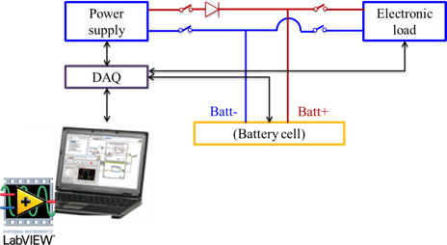

**Figure 4.1 Charge/Discharge Characteristics Test Configuration**

* 1. Lot Sampling Test

Thermal test of battery cell is performed for confirmation of temperature tolerance. Test condition is summarized as below.

- Temperature: more than +60 degree C

- Test Duration: Over 2 hours

Before and after the thermal test, several function tests below are performed to see that there is no change in characteristics.

- Visual inspection (scratches, misaligned seals, electrolyte leakage etc.)

- Open Circuit Voltage

- Mass

- Capacity

- Charge/Discharge Characteristic

- Discharge Temperature

## Test Results

* 1. Acceptance Test

1. Random Vibration Test

Test configuration is shown on Figure 5.1-1-1. Test result is referred to Figure 5.1-1-2 and Figure 5.1-1-3.

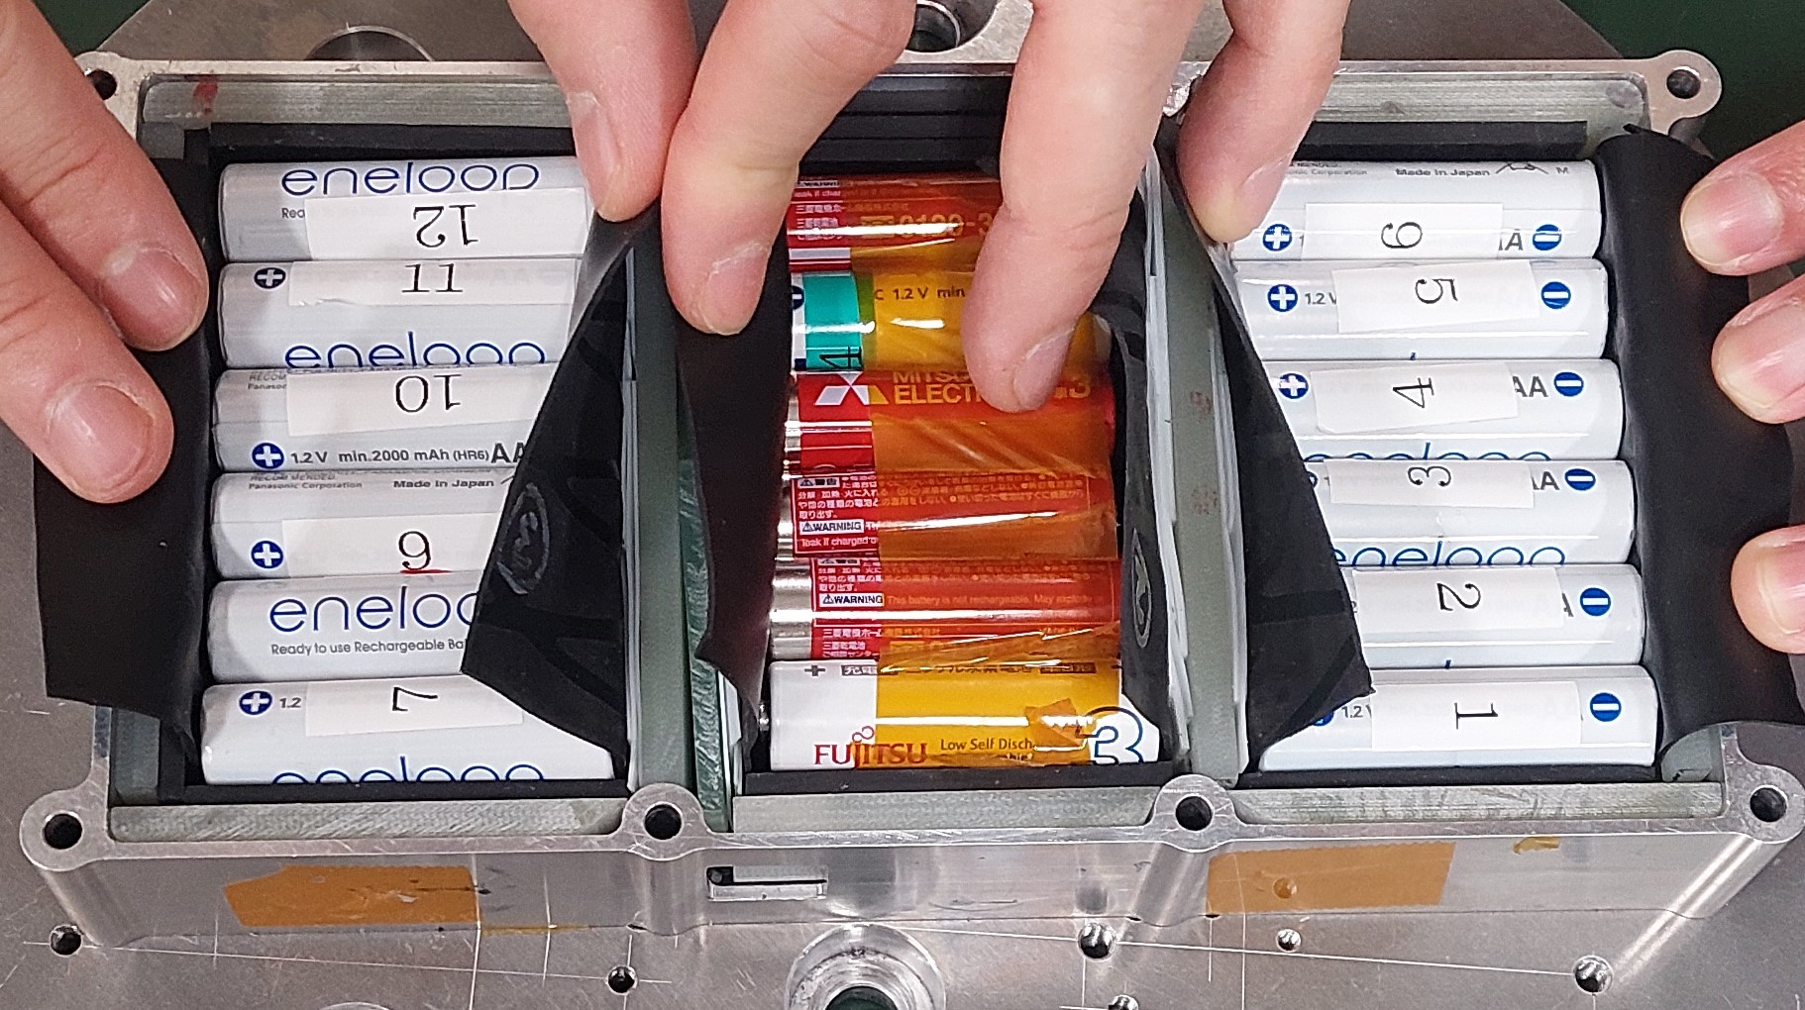(a)Battery Set Up

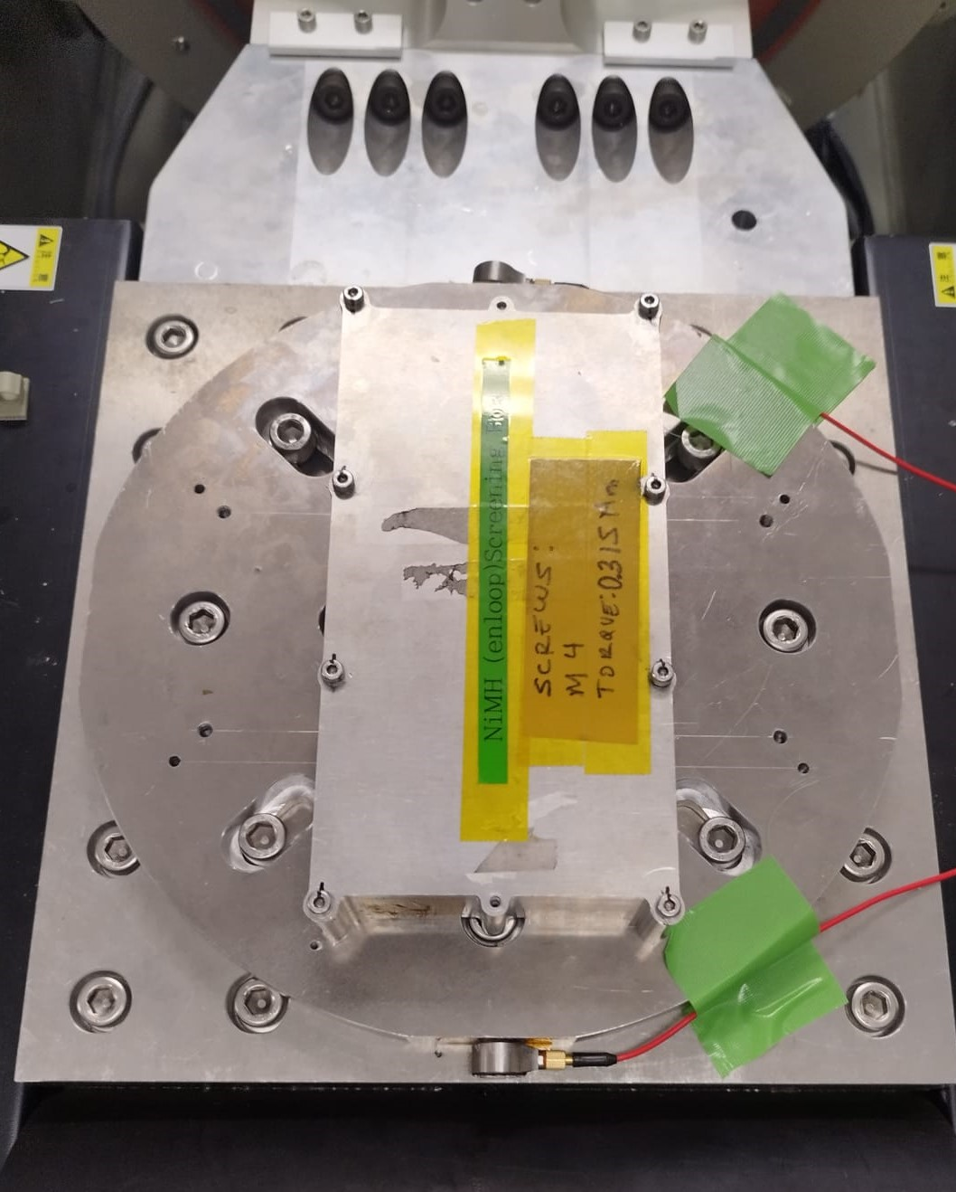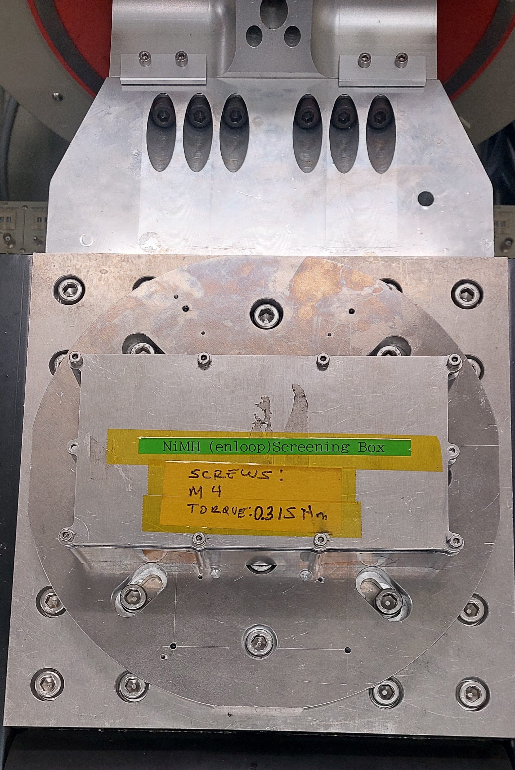

(b)Radial axis (c)Axial axis

**Figure 5.1-1-1 Test Configuration for Battery Random Vibration Test**



**Figure 5.1-1-2 Random Vibration Test Result (Radial direction)**



**Figure 5.1-1-3 Random Vibration Test Result (Axial direction)**

1. Vacuum Test

Test configuration is shown on Figure 5.1-2-1. Test result is referred to Figure 5.1-2-2.

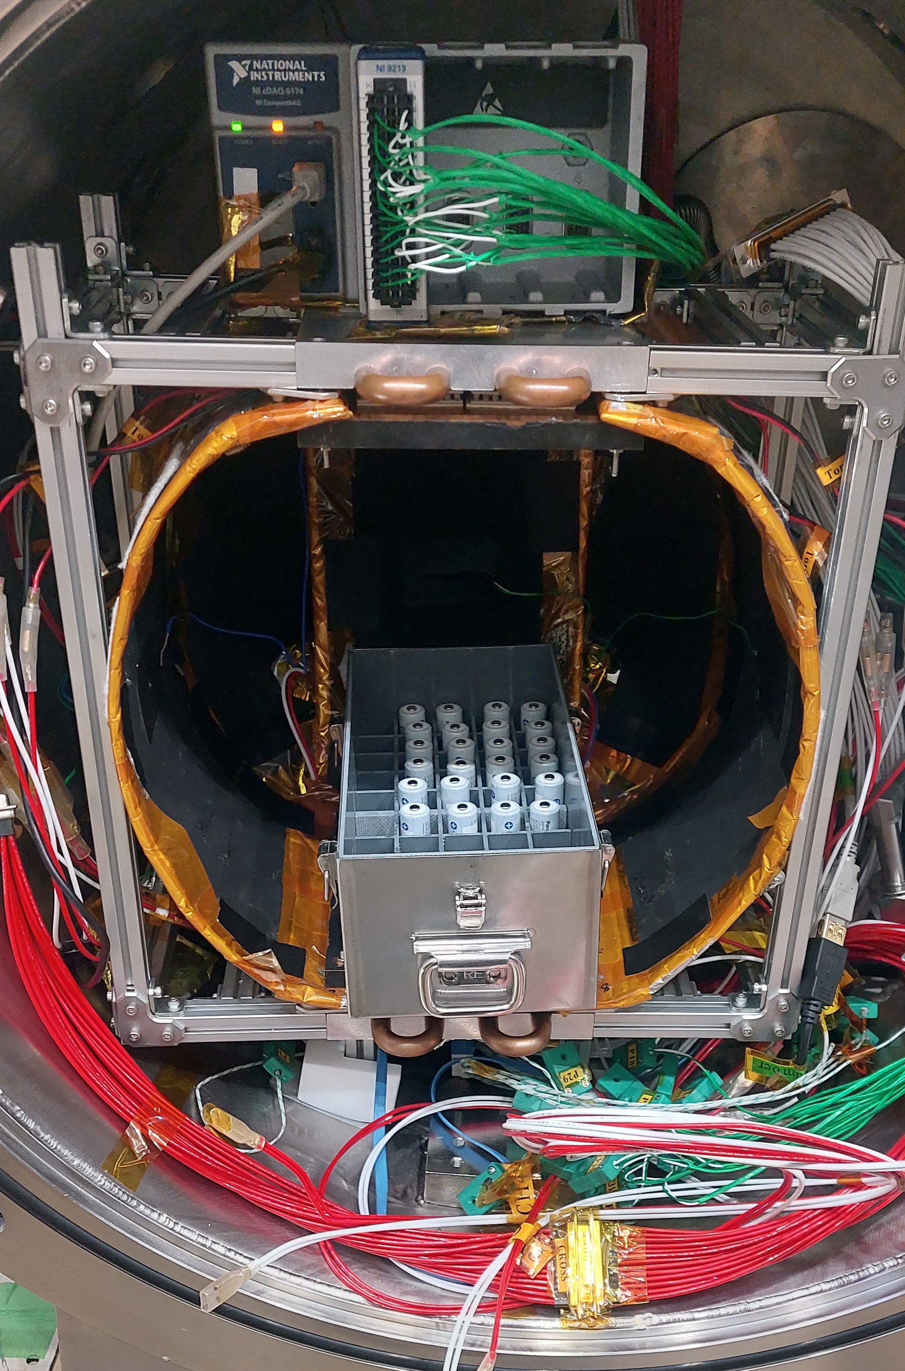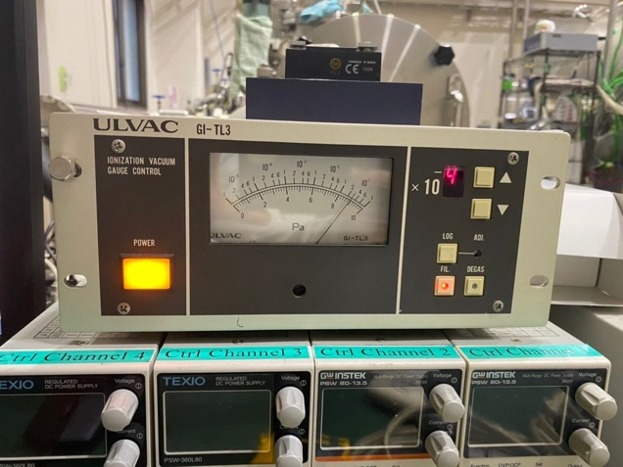

**Figure 5.1-2-1 Test Configuration for Battery Vacuum Test**

**Figure 5.1-2-2 Vacuum Test Result**

1. Function Test

Test configuration is shown on Figure 5.1-3-1. Test result is referred to Figure 5.1-3-2 to Figure 5.1-3-7, Table 5.1-3-1 and Table 5.1-3-2. In Figures 5.1-3-2 to 5.1-3-7, 1st cycle refers to “Before Vacuum Test”, 2nd Cycle is “After Vacuum Test” and 3rd Cycle is “After Vibration Test” for the DRAGONFLY FM batteries.

 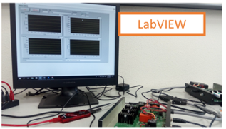

**Figure 5.1-3-1 Test Configuration for Battery Function Test**

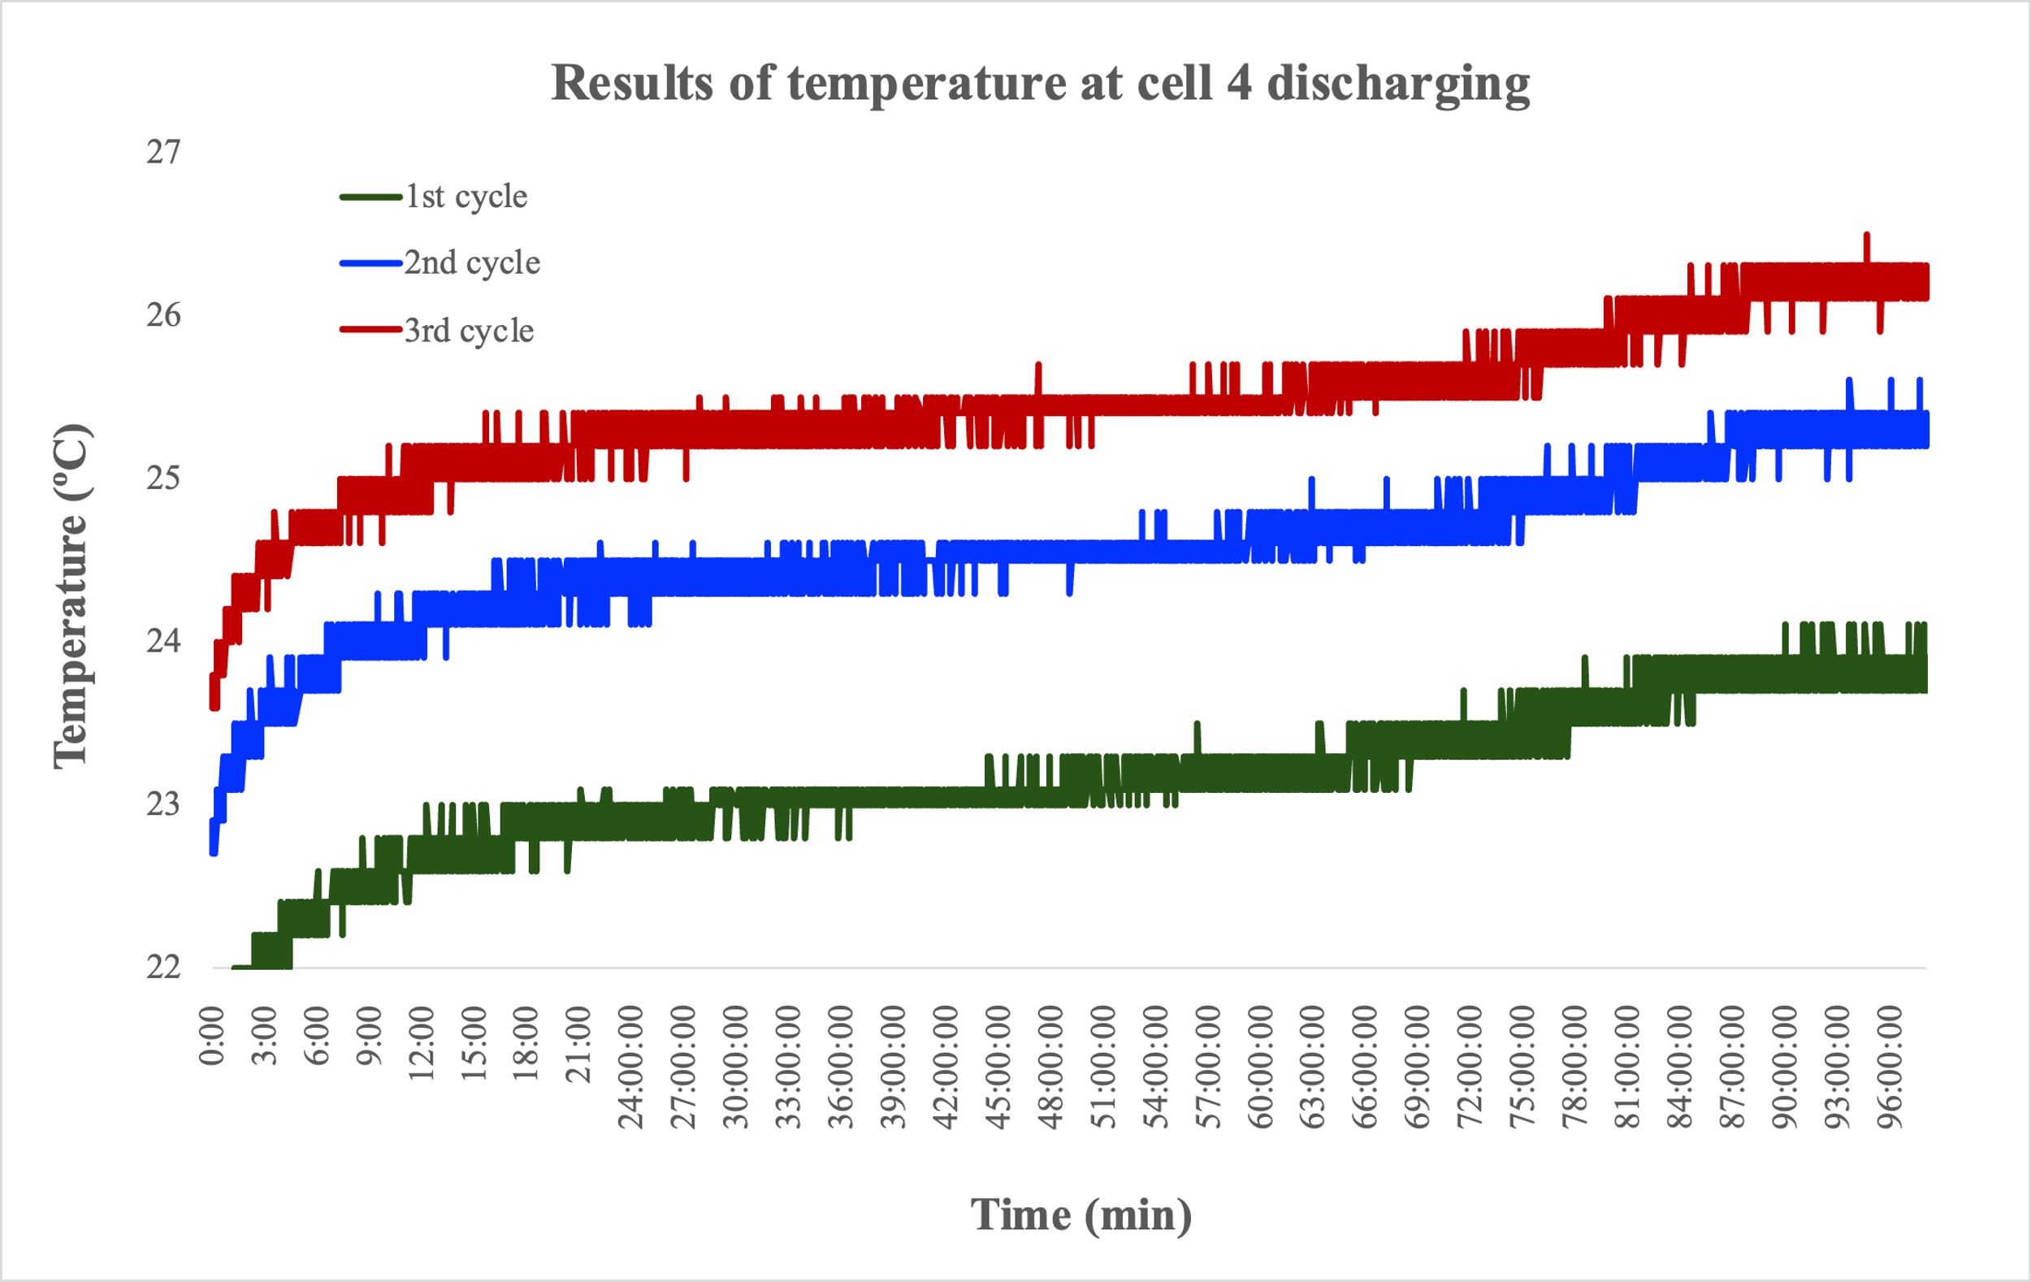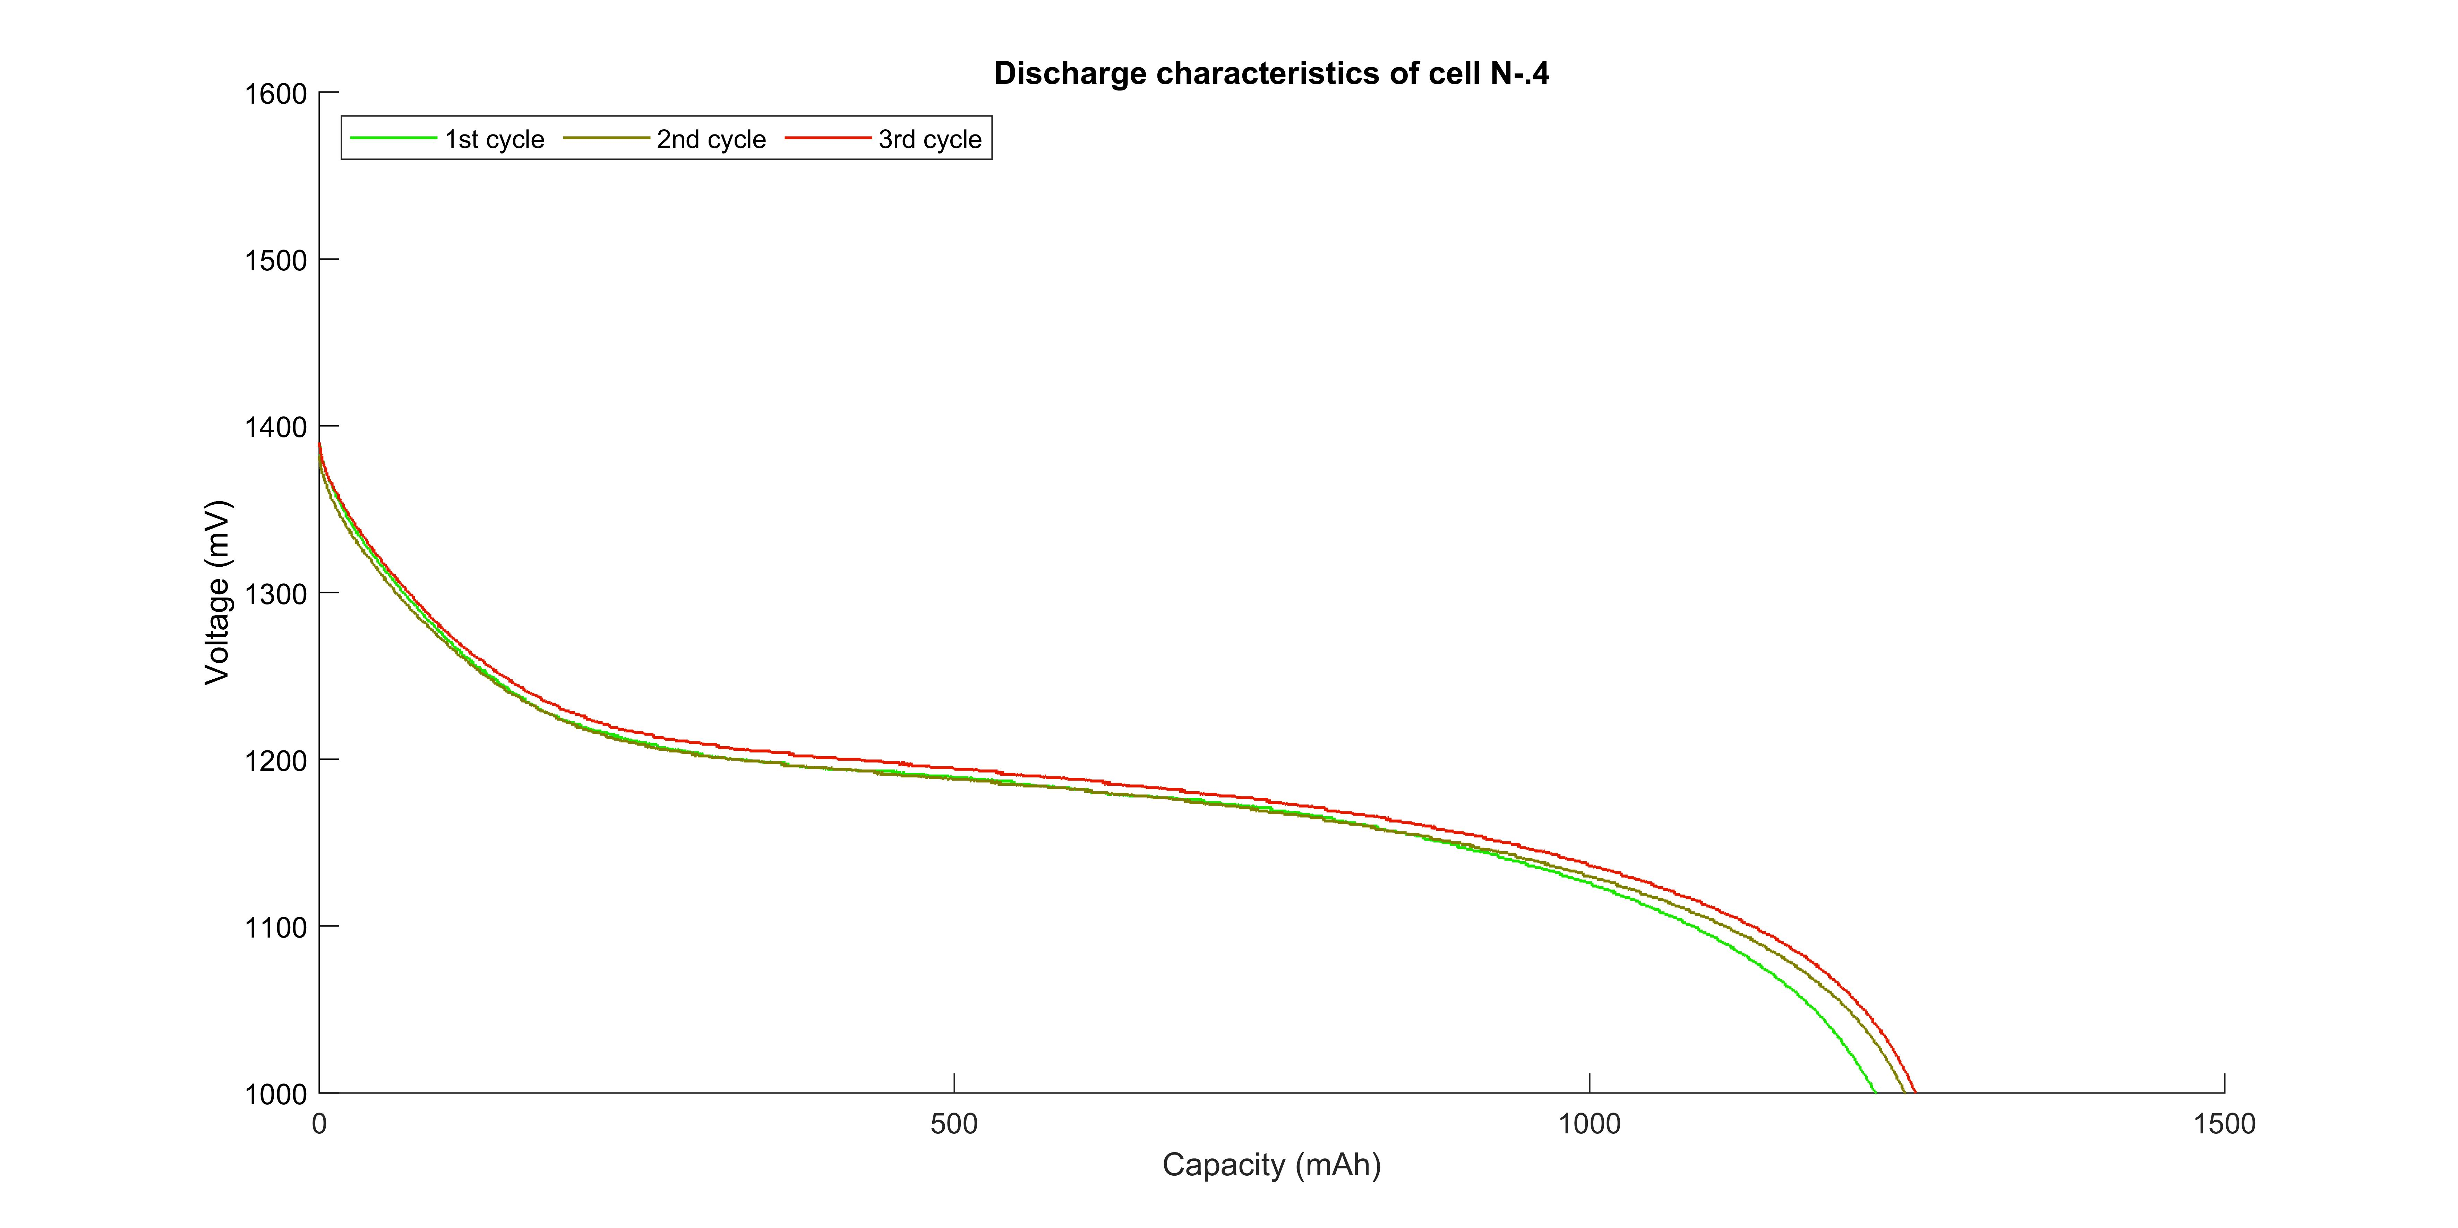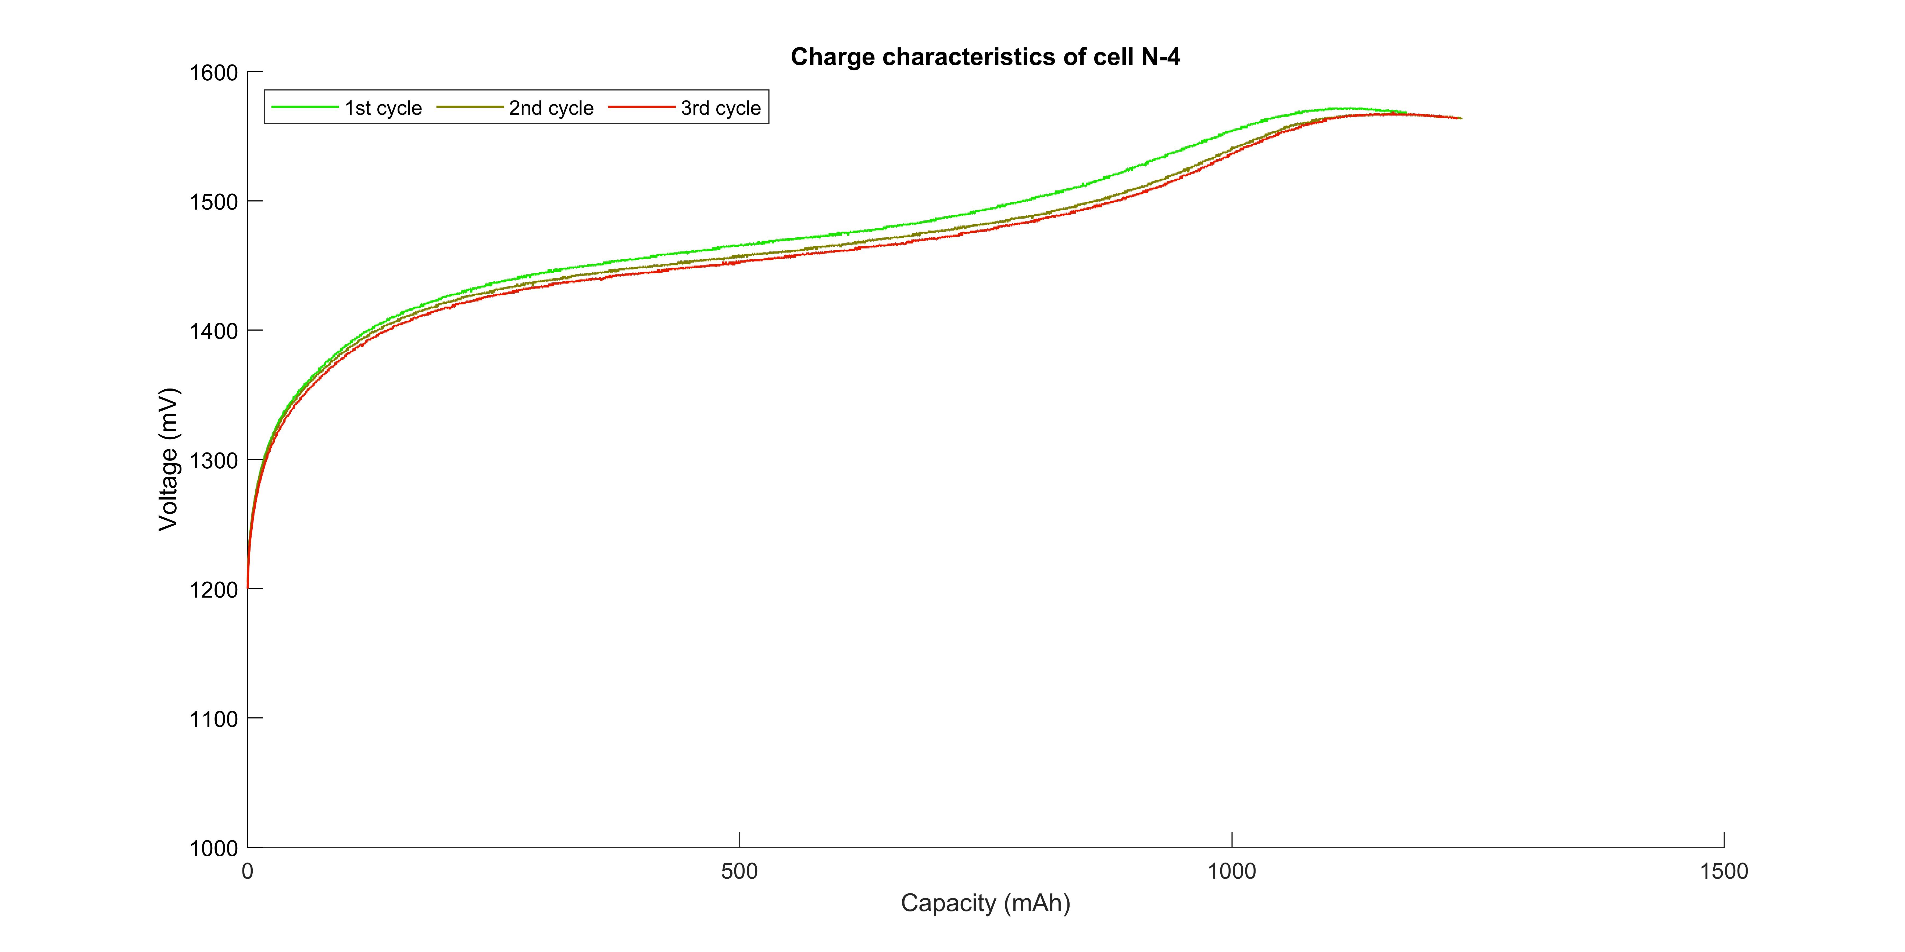

Voltage / mV

Voltage / mV

**Figure 5.1-3-2 Function Test Results for cell #4**

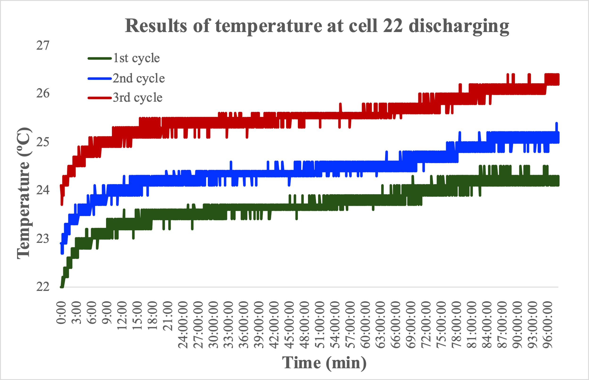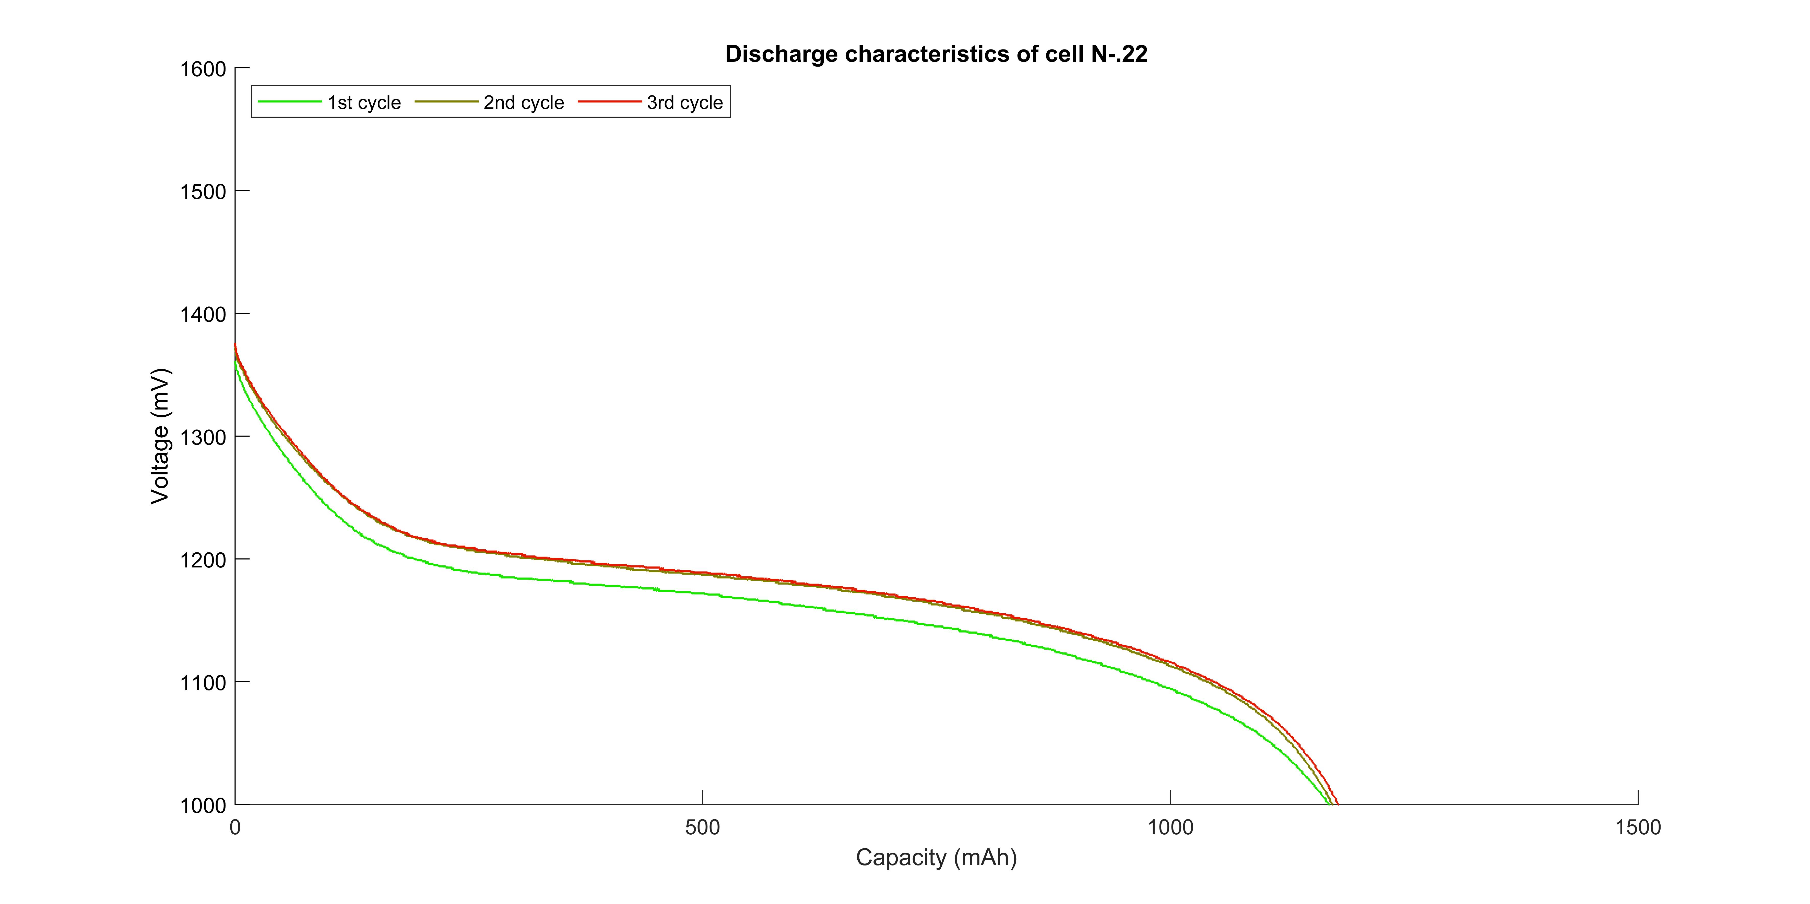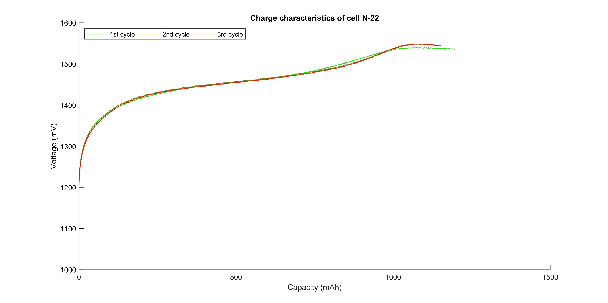

**Figure 5.1-3-3 Function Test Results for cell #22**

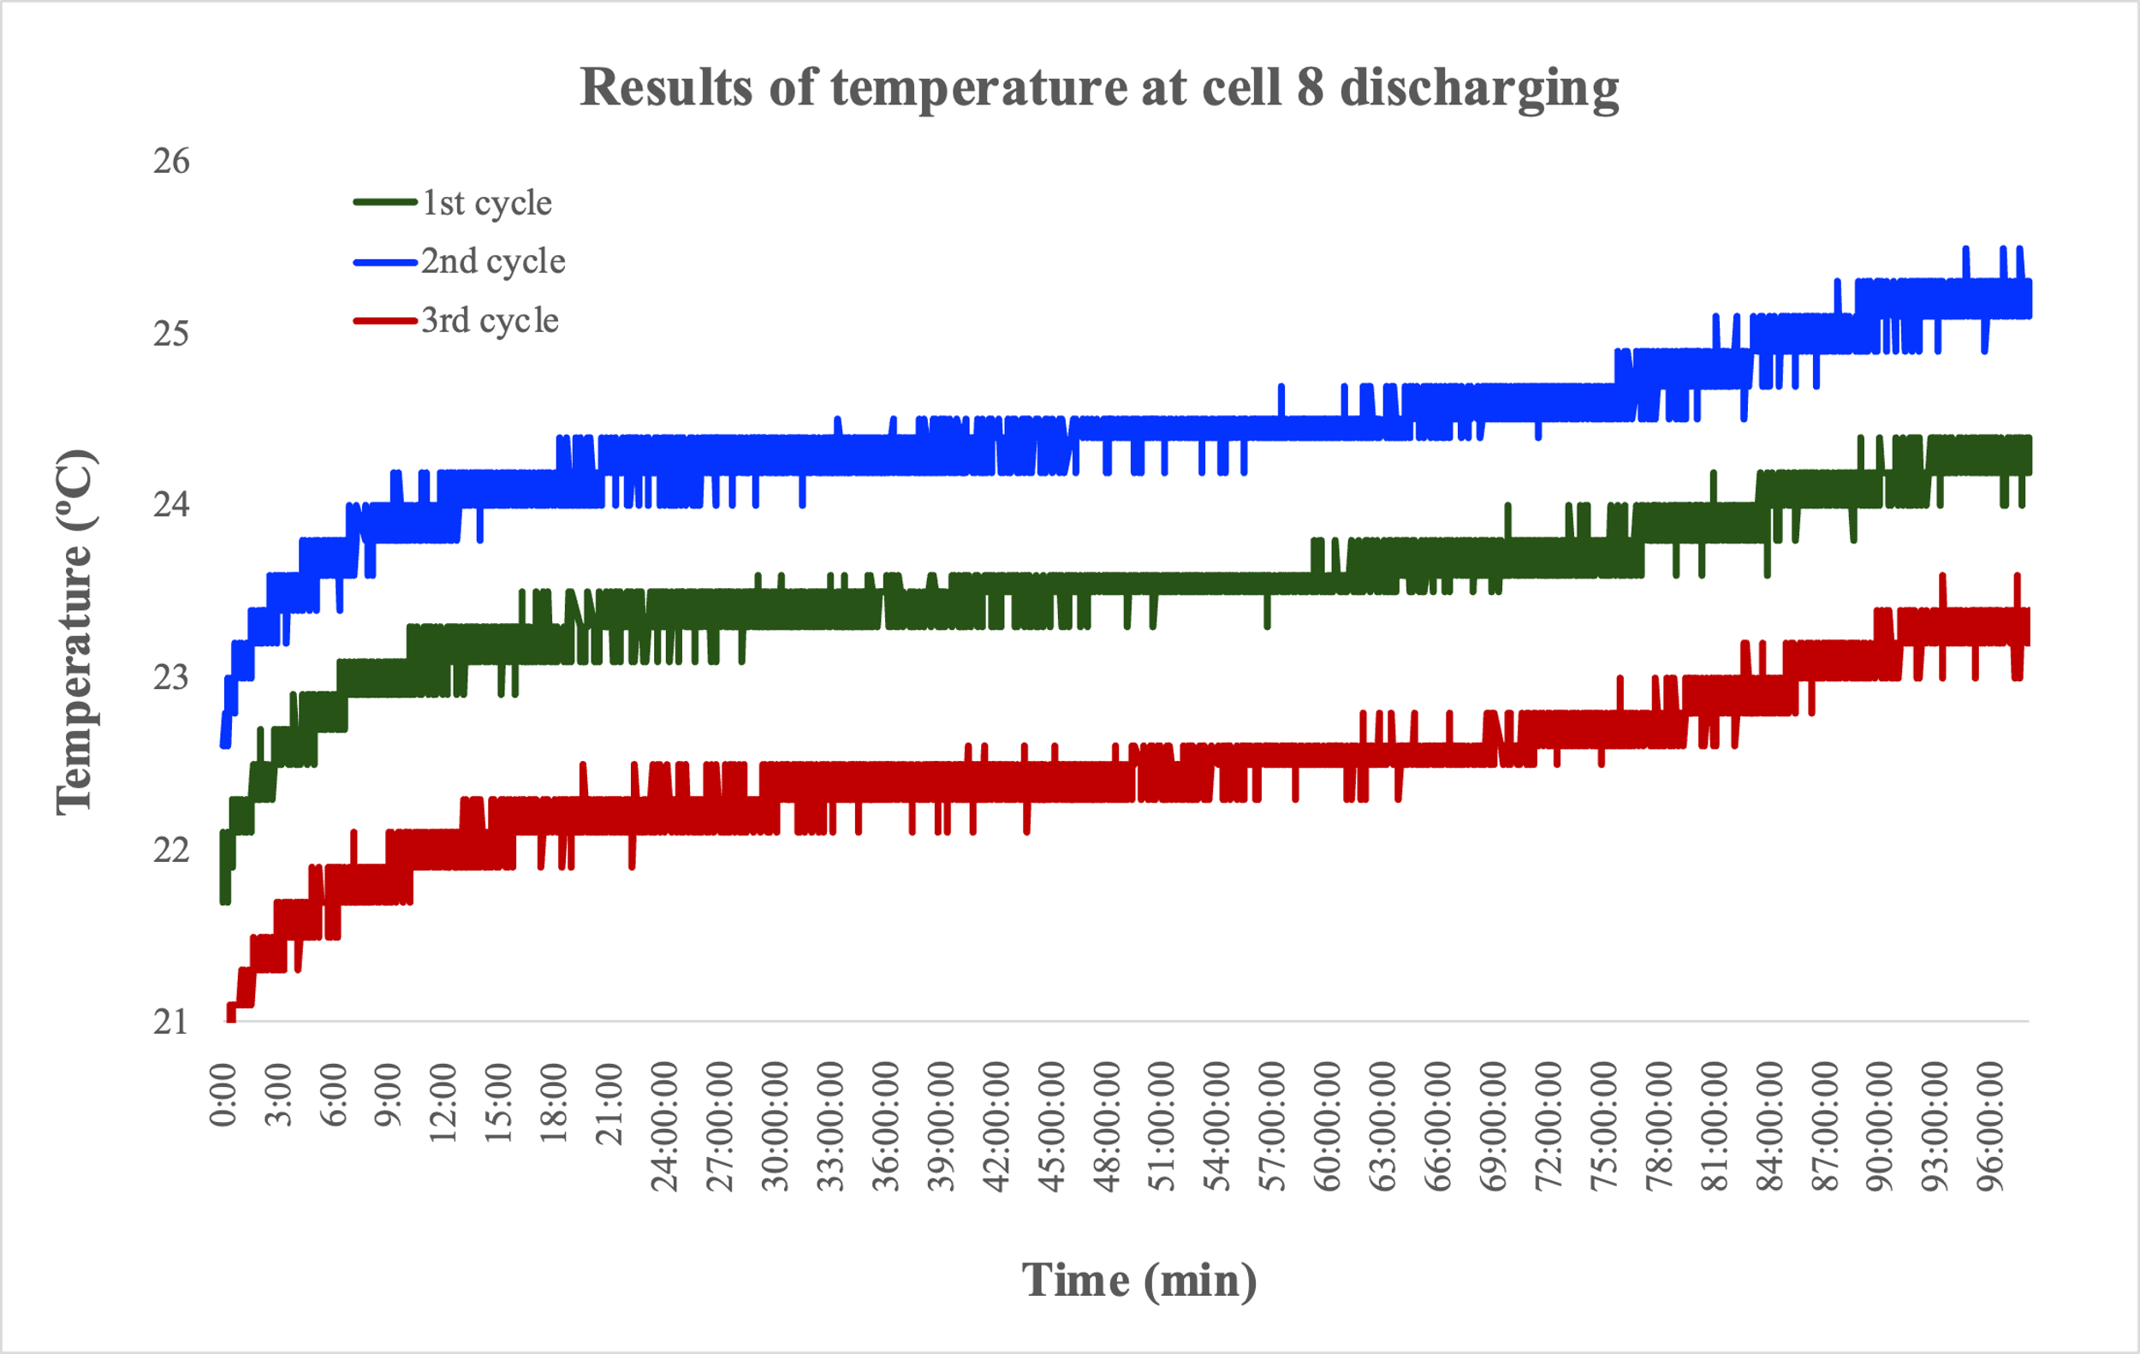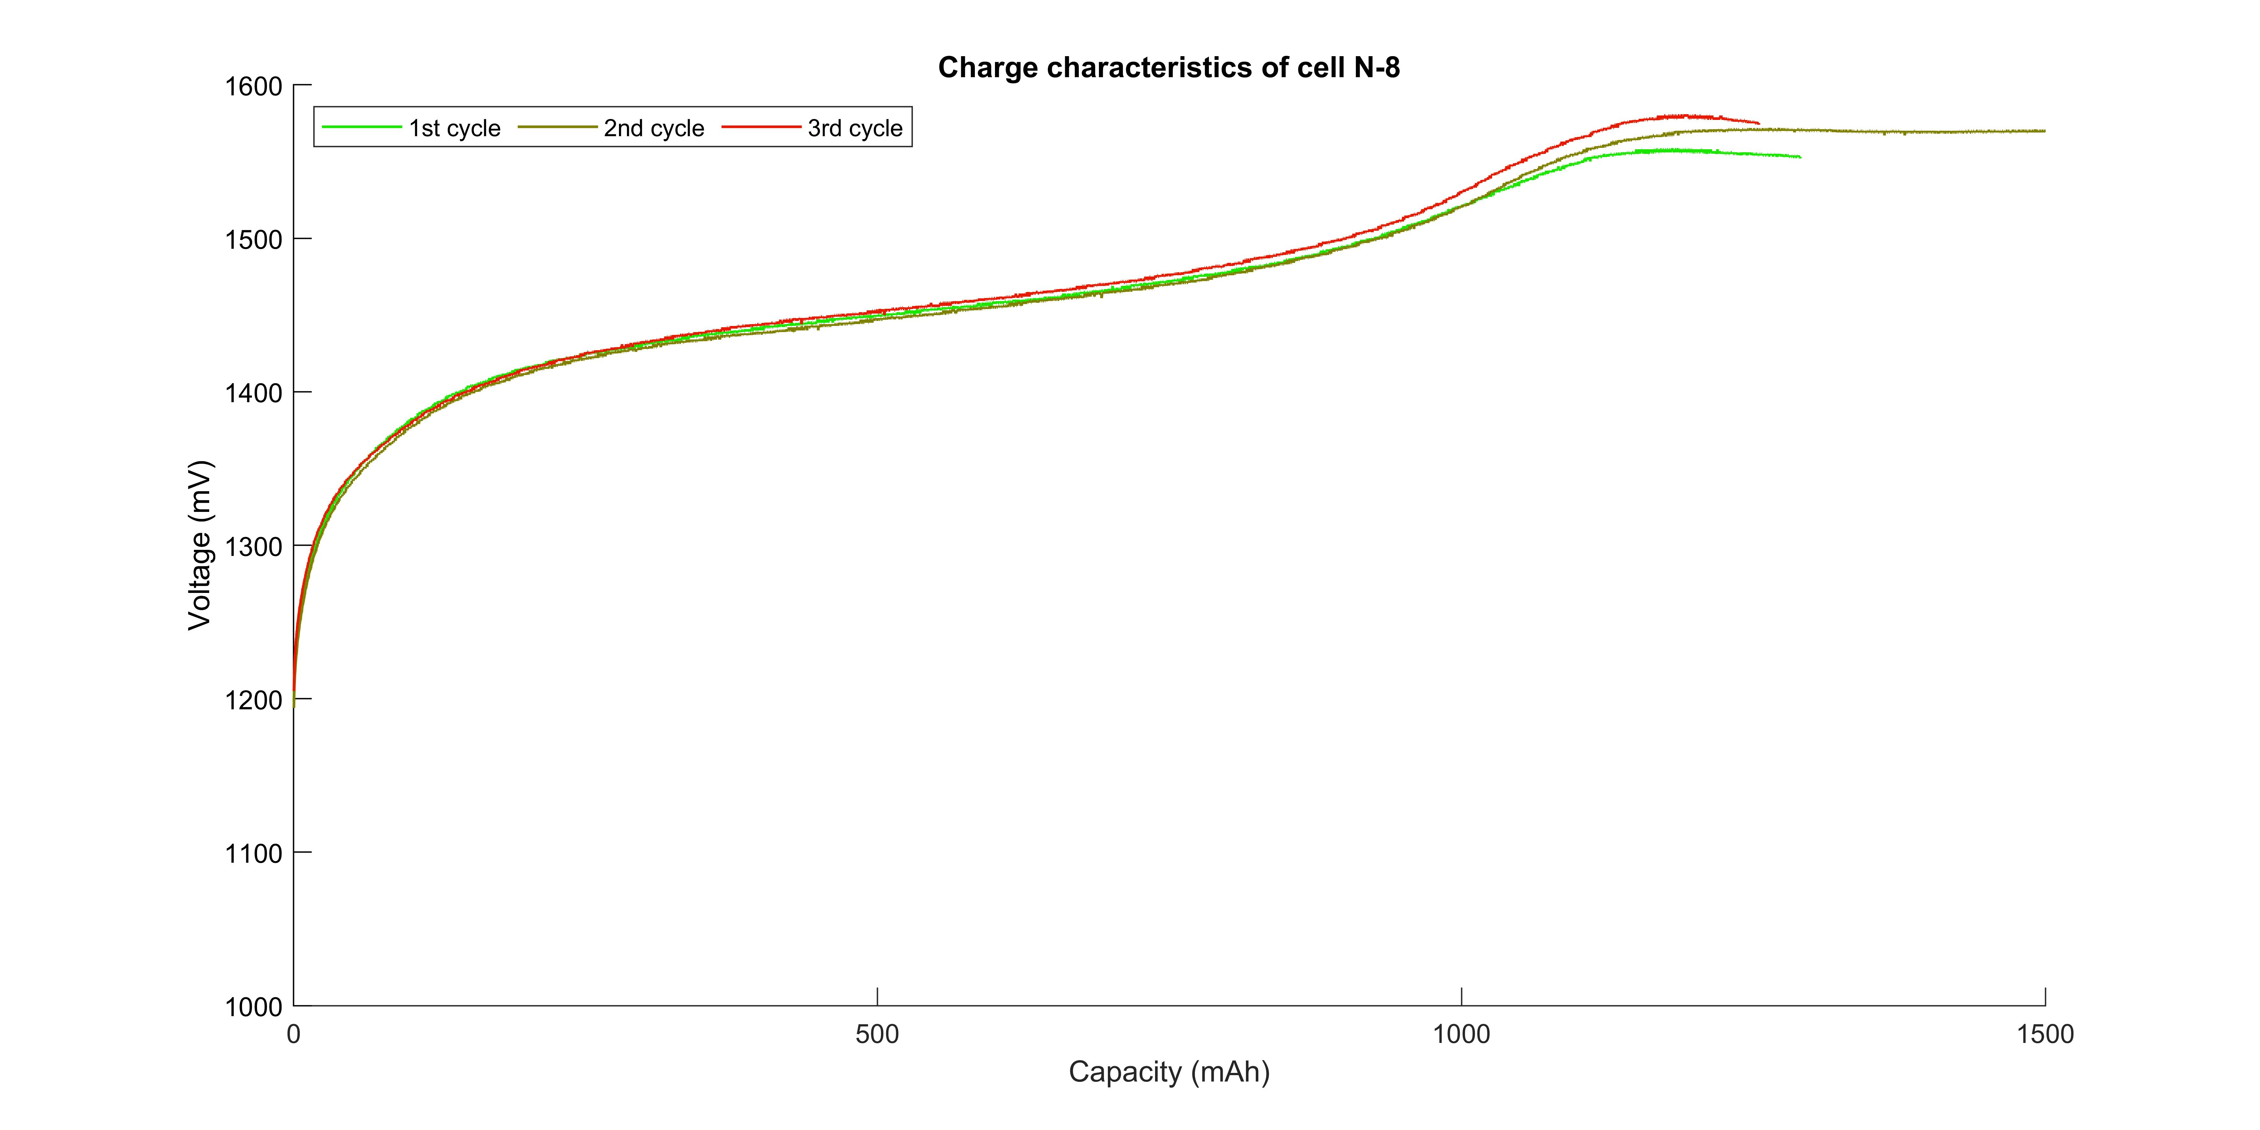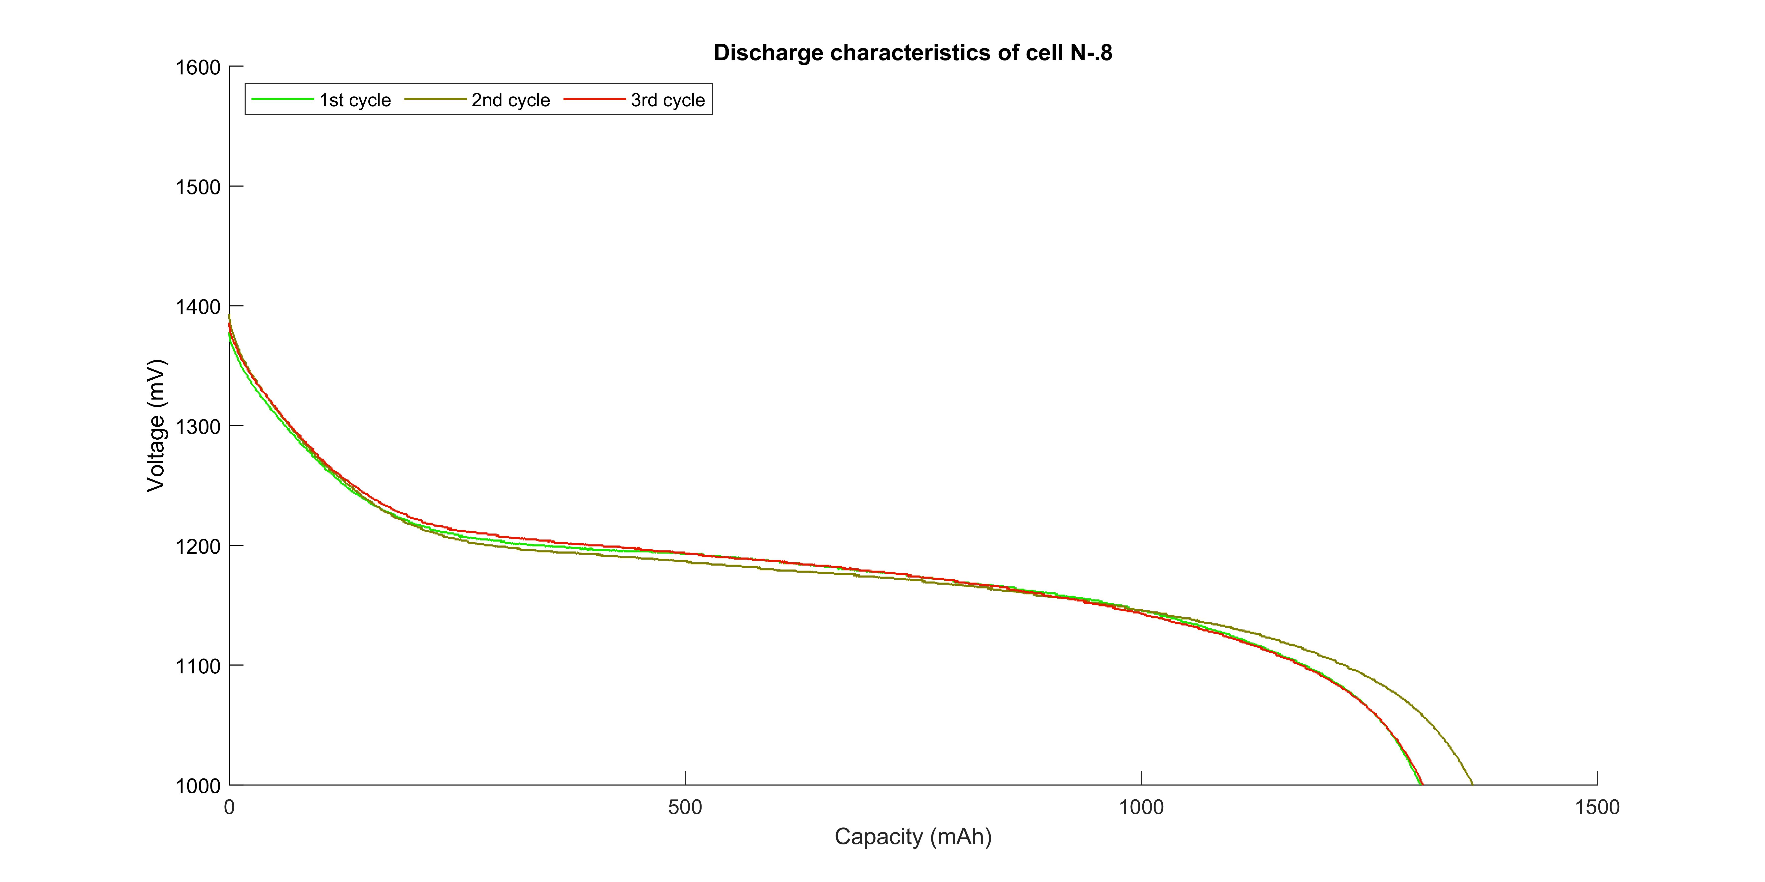

Voltage / mV

Voltage / mV

Voltage / mV

Voltage / mV

Voltage / mV

Voltage / mV

Voltage / mV

Voltage / mV

**Figure 5.1-3-4 Function Test Results for cell #8**

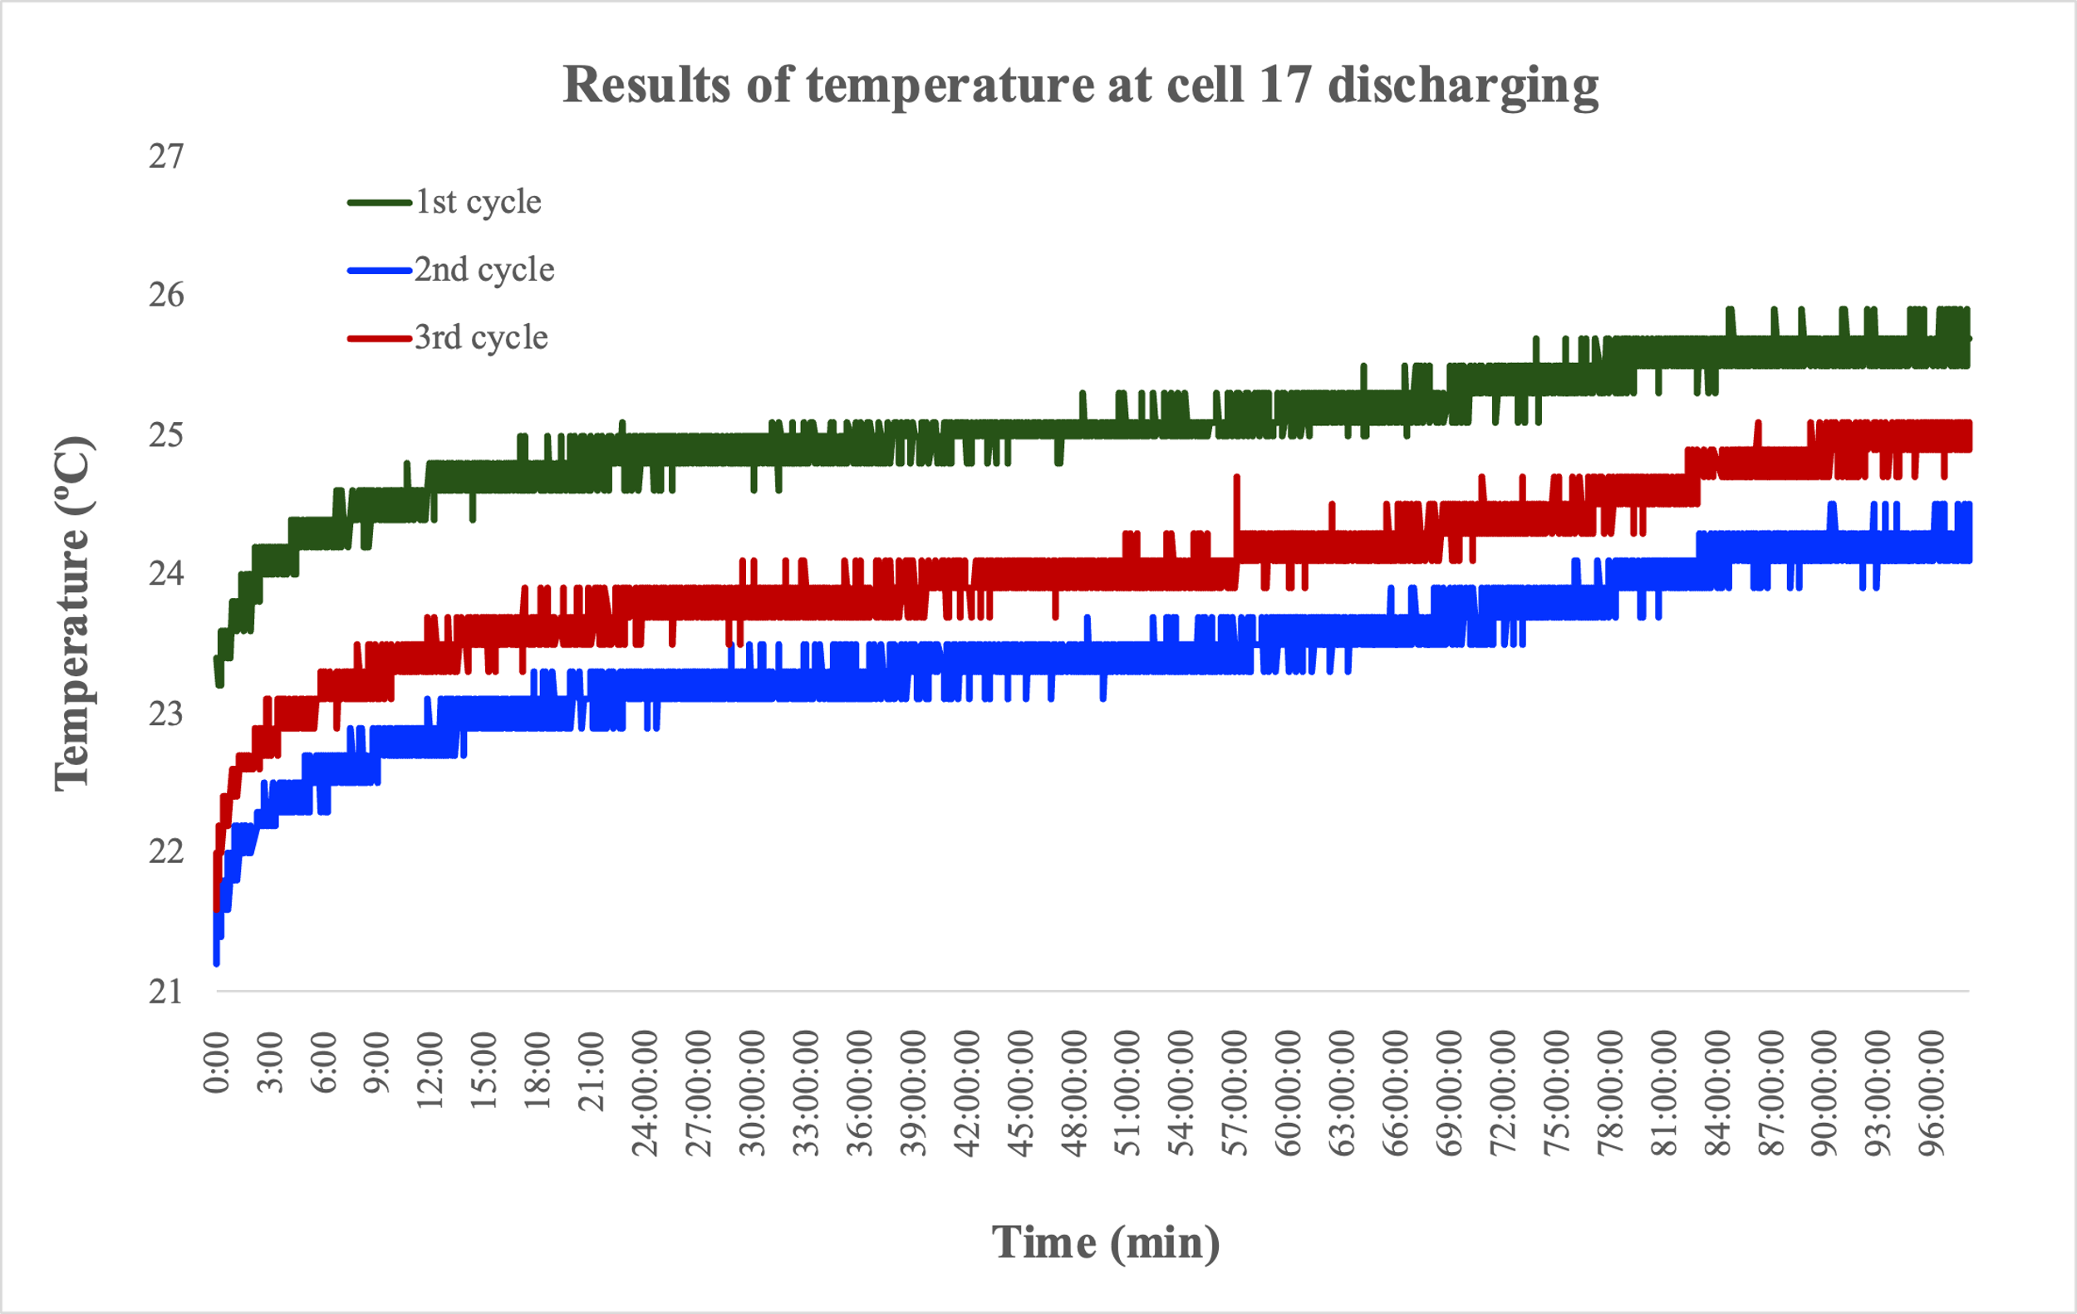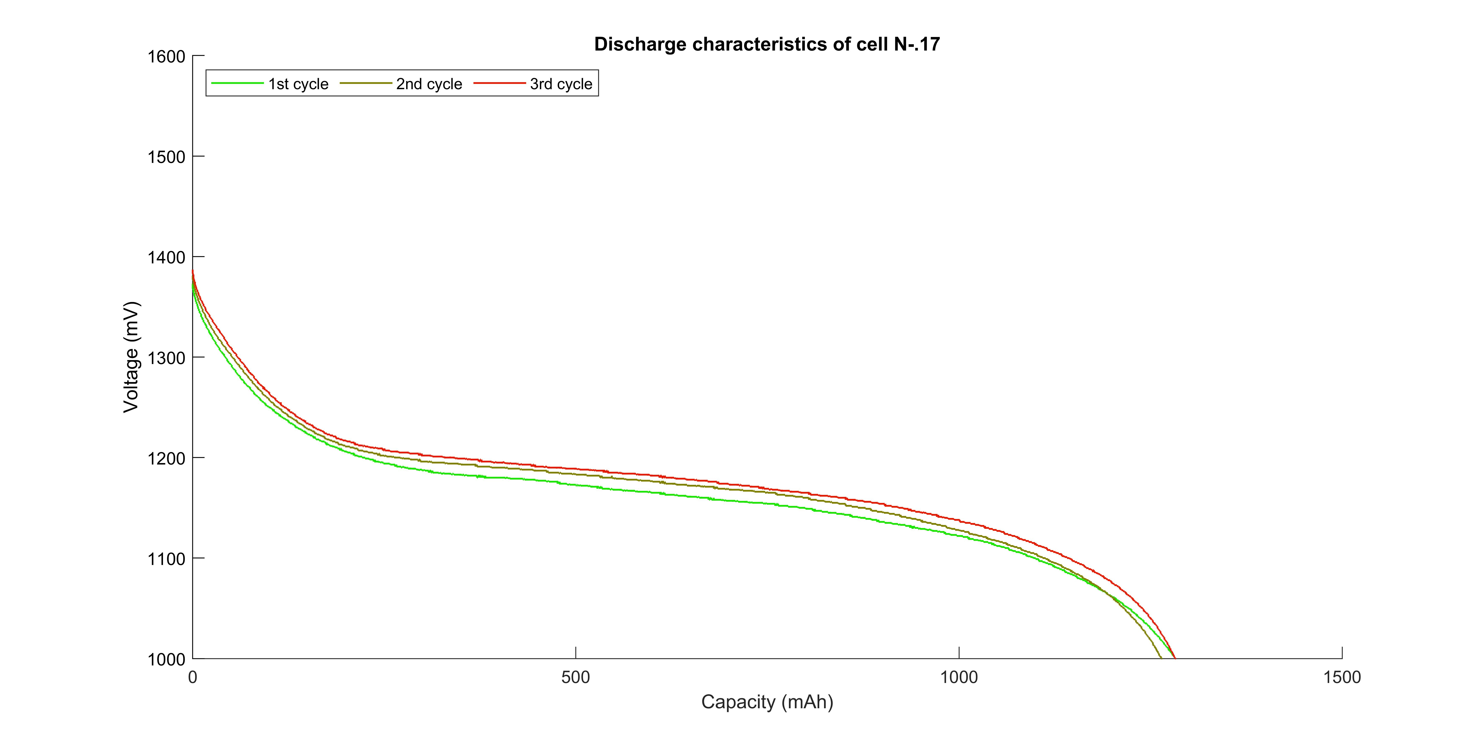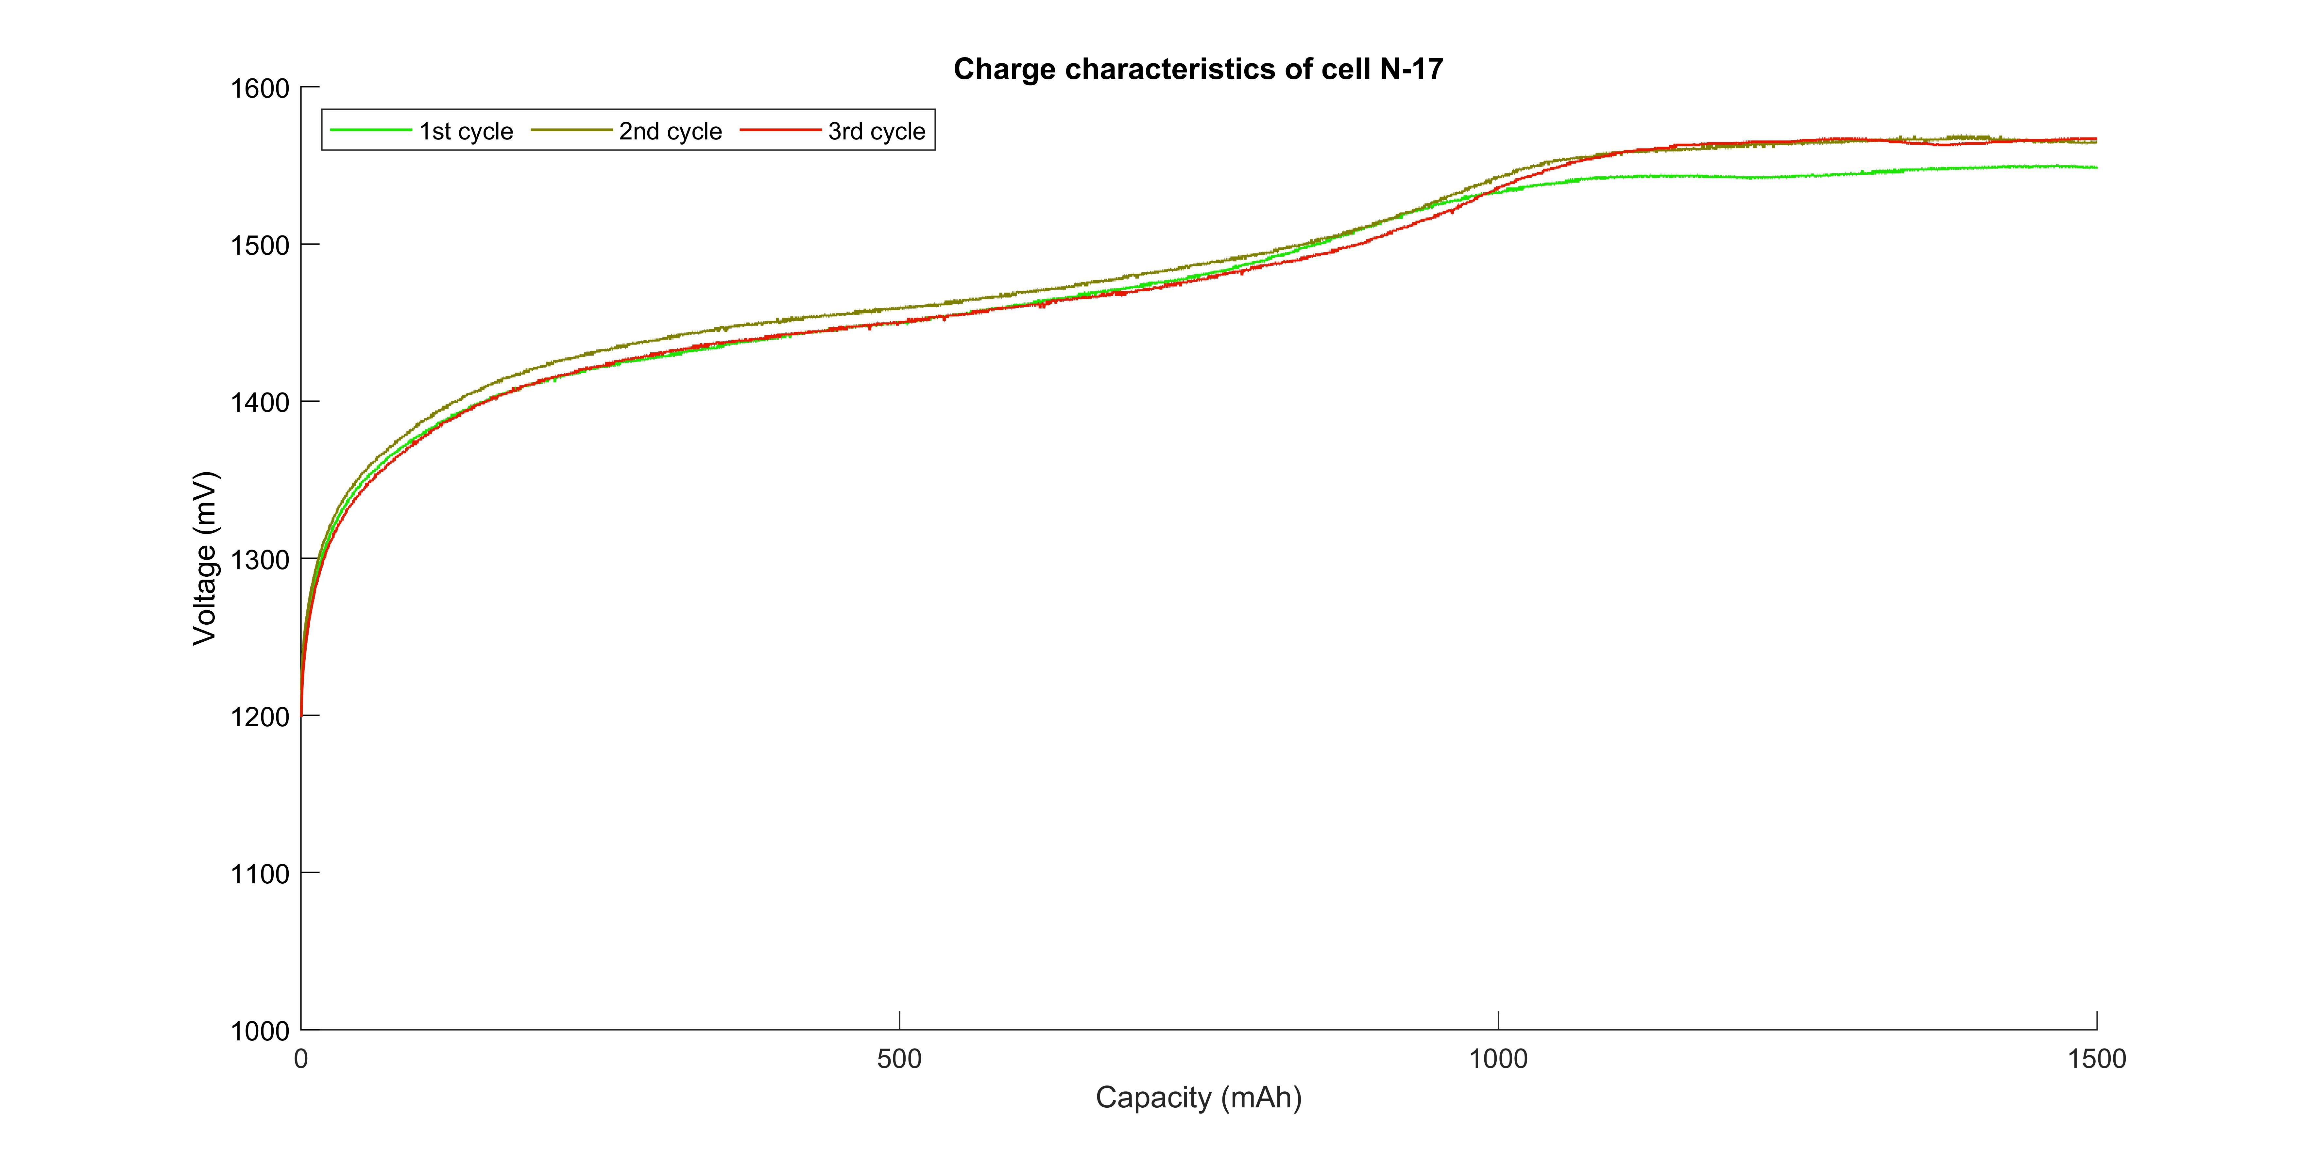**Figure 5.1-3-5 Function Test Results for cell #17**

Voltage / mV

Voltage / mV

Voltage / mV

Voltage / mV

Voltage / mV

Voltage / mV

Voltage / mV

Voltage / mV

Voltage / mV

Voltage / mV

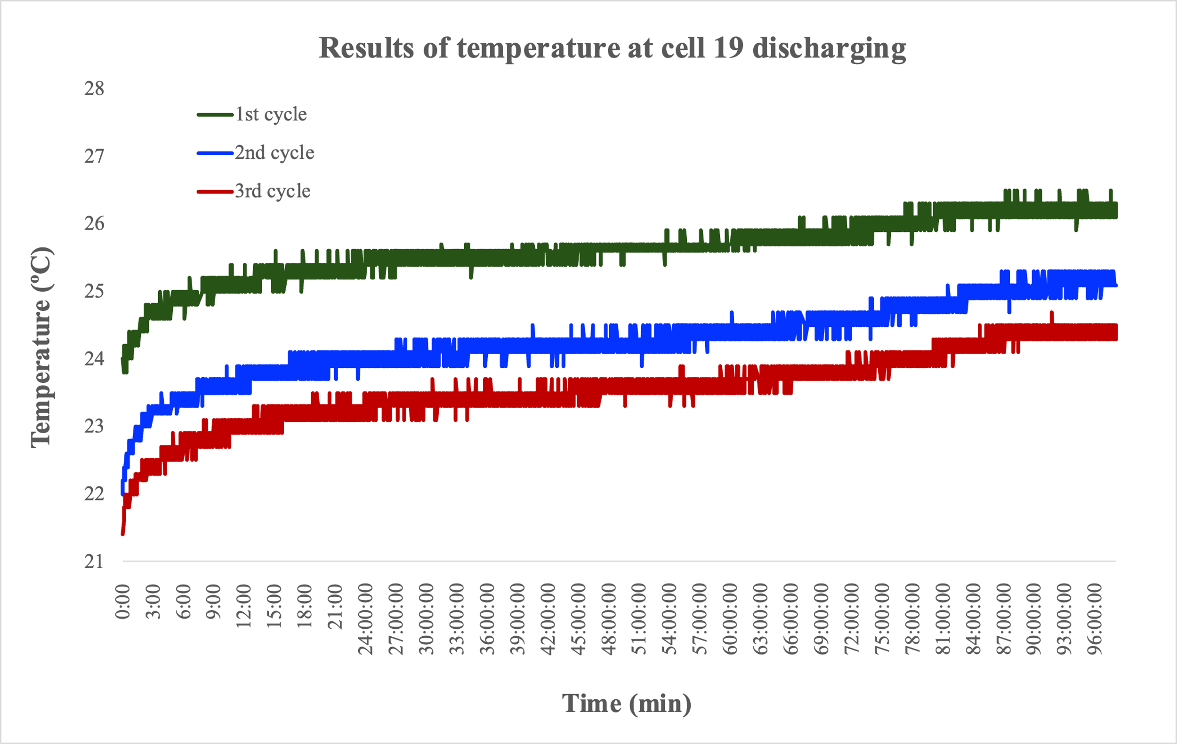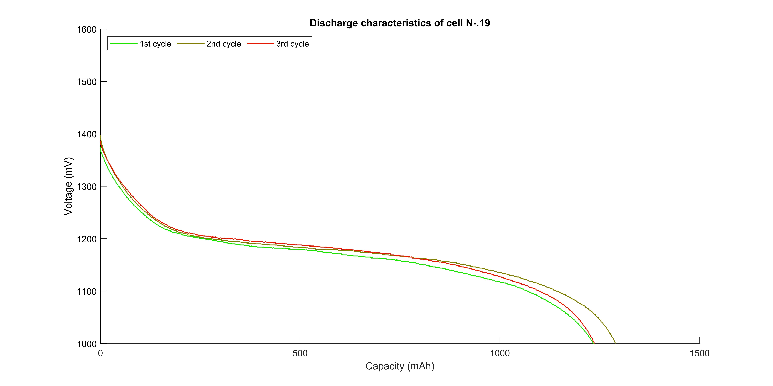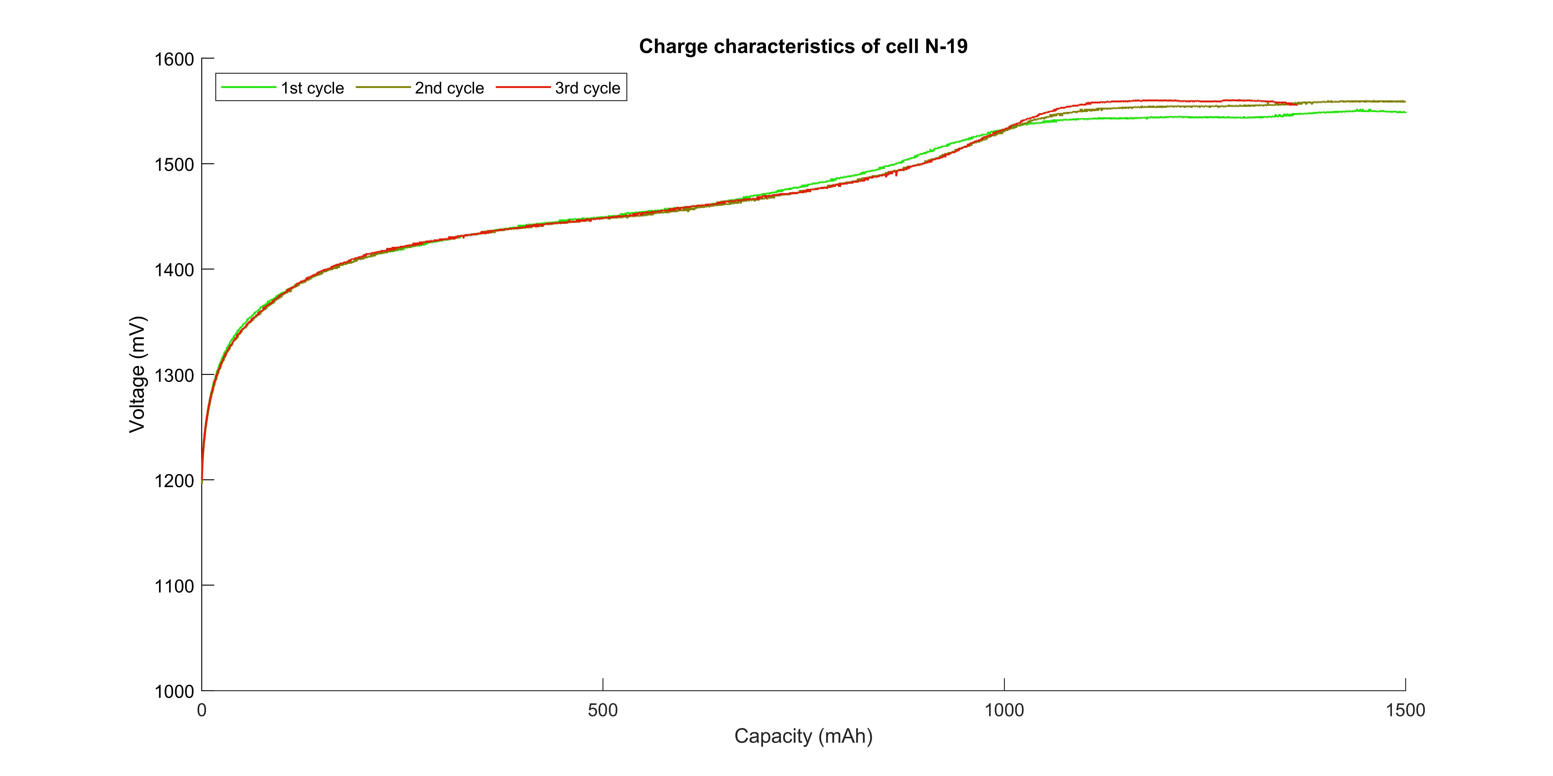

**Figure 5.1-3-6 Function Test Results for cell #19**

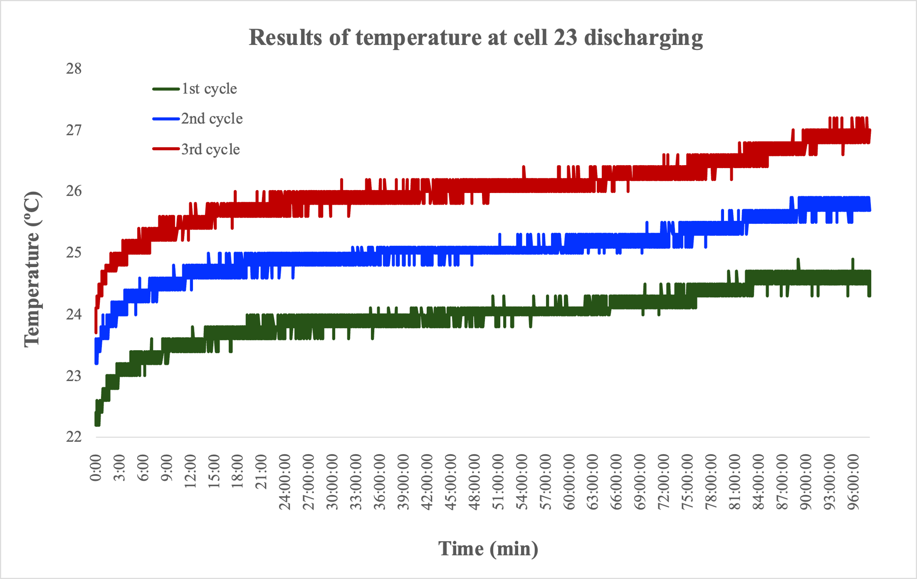

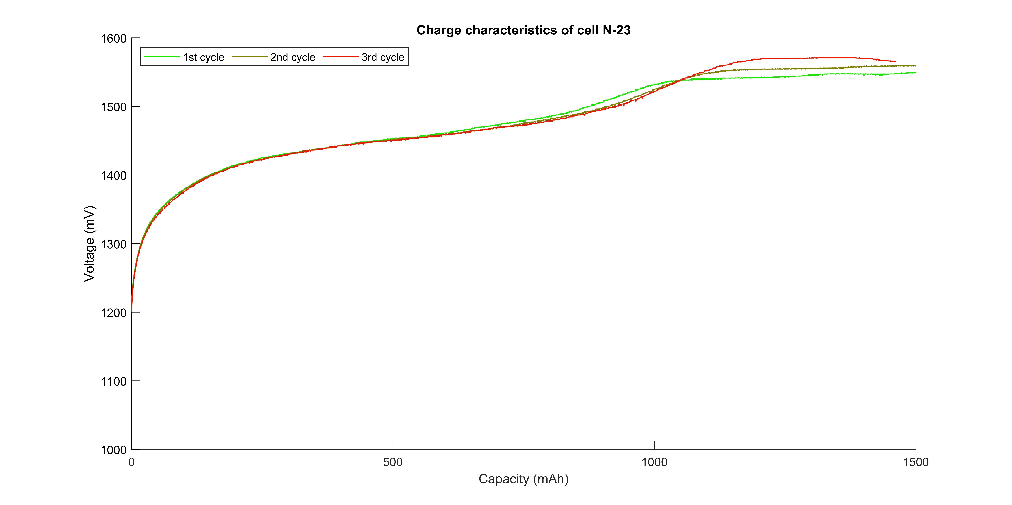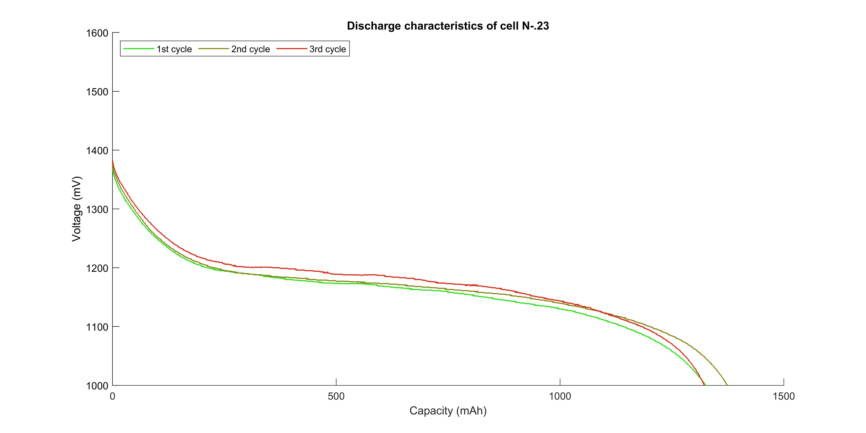**Figure 5.1-3-7 Function Test Results for cell #23**

**Table 5.1-3-2 Measurement Result of Function Test before and after Vacuum test**

|  |  |  |  |  |  |  |  |  |  |  |  |  |
| --- | --- | --- | --- | --- | --- | --- | --- | --- | --- | --- | --- | --- |
| ***BIRDS-X Cell Screening - Before and after Vacccum Test*** | | | | | | | | | | | | |
| **Cell No** | **Before** | | | | **After** | | | | **Difference** | | | **Status** |
| **OCV**  **[V]** | **Discharge Capacity** | **Mass** | **Visual Ins.** | **OCV [V]** | **Discharge Capacity** | **Mass** | **Visual Ins.** | **OCV** | **Capacity** | **Mass** |  |
| [mAh] | [g] | [mAh] | [g] | [<0.1%] | [<5%] | [<0.1%] |  |
| 4 | 1.336 | 1226 | 24.653 | OK | 1.335 | 1249 | 24.654 | Ok | 0.07% | 1.88% | 0.00% | PASS |
| 8 | 1.332 | 1306.6 | 25.000 | OK | 1.331 | 1364.2 | 25.000 | Ok | 0.08% | 4.41% | 0.00% | PASS |
| 17 | 1.336 | 1283.2 | 24.807 | OK | 1.336 | 1265.2 | 24.807 | Ok | 0.00% | 1.40% | 0.00% | PASS |
| 19 | 1.338 | 1235 | 24.454 | OK | 1.338 | 1290.6 | 24.454 | Ok | 0.00% | 4.50% | 0.00% | PASS |
| 22 | 1.339 | 1170.4 | 24.103 | OK | 1.338 | 1173.8 | 24.107 | Ok | 0.07% | 0.29% | 0.02% | PASS |
| 23 | 1.342 | 1326.8 | 25.127 | OK | 1.341 | 1374.4 | 25.126 | Ok | 0.07% | 3.59% | 0.00% | PASS |

*Percentage shows the difference before and after the environment test

**Table 5.1-3-3 Measurement Result of Function Test before and after vibration test**

|  |  |  |  |  |  |  |  |  |  |  |  |  |
| --- | --- | --- | --- | --- | --- | --- | --- | --- | --- | --- | --- | --- |
| ***BIRDS-X Cell Screening - Before and after Vibration Test*** | | | | | | | | | | | | |
| **Cell No.** | **Before** | | | | **After** | | | | **Difference** | | | **Status** |
| **OCV**  **[V]** | **Discharge Capacity** | **Mass** | **Visual Ins.** | **OCV [V]** | **Discharge Capacity** | **Mass** | **Visual Ins.** | **OCV** | **Capacity** | **Mass** |
| [mAh] | [g] | [mAh] | [g] | [<0.1%] | [<5%] | [<0.1%] |
| 4 | 1.341 | 1249 | 24.653 | OK | 1.342 | 1257.6 | 24.65 | OK | 0.07% | 0.69% | 0.01% | PASS |
| 8 | 1.34 | 1364.2 | 24.984 | OK | 1.341 | 1309.4 | 24.988 | OK | 0.07% | 4.02% | 0.02% | PASS |
| 17 | 1.345 | 1265.2 | 24.806 | OK | 1.345 | 1282.8 | 24.803 | OK | 0.00% | 1.39% | 0.01% | PASS |
| 19 | 1.347 | 1290.6 | 24.449 | OK | 1.346 | 1237.6 | 24.451 | OK | 0.07% | 4.11% | 0.01% | PASS |
| 22 | 1.364 | 1173.8 | 24.103 | OK | 1.363 | 1180.2 | 24.105 | OK | 0.07% | 0.55% | 0.01% | PASS |
| 23 | 1.347 | 1374.4 | 25.124 | OK | 1.347 | 1323.2 | 25.126 | OK | 0.00% | 3.73% | 0.01% | PASS |

*Percentage shows the difference before and after the environment test

* 1. **Lot Sampling Test**

Test configuration is shown on Figure 5.2-1. Test result is referred to Figure 5.2-2, Figure 5.2-3 and Table 5.2-1.

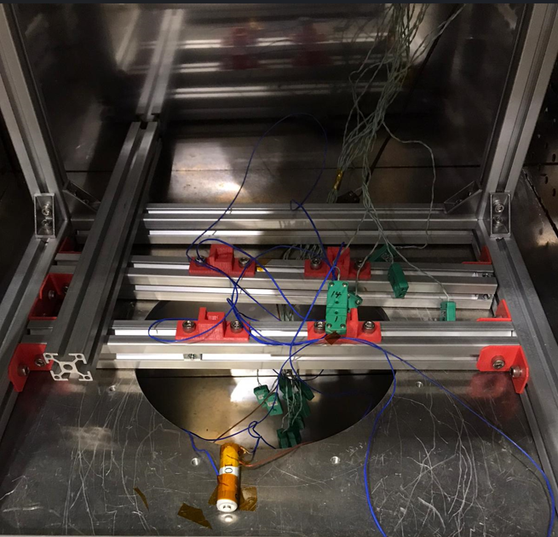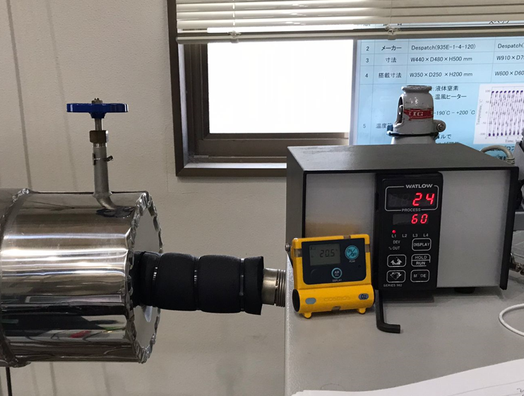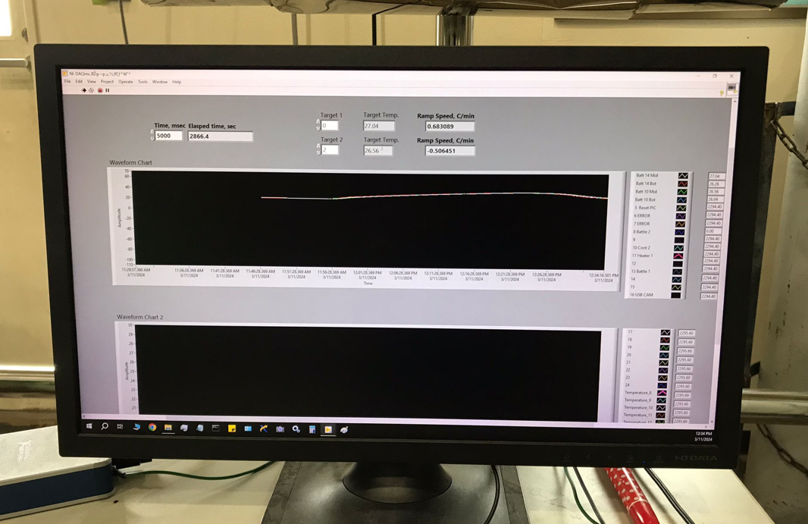

**Figure 5.2-1 Test Configuration for Thermal Test**

Figure 5.2-2 Thermal test result

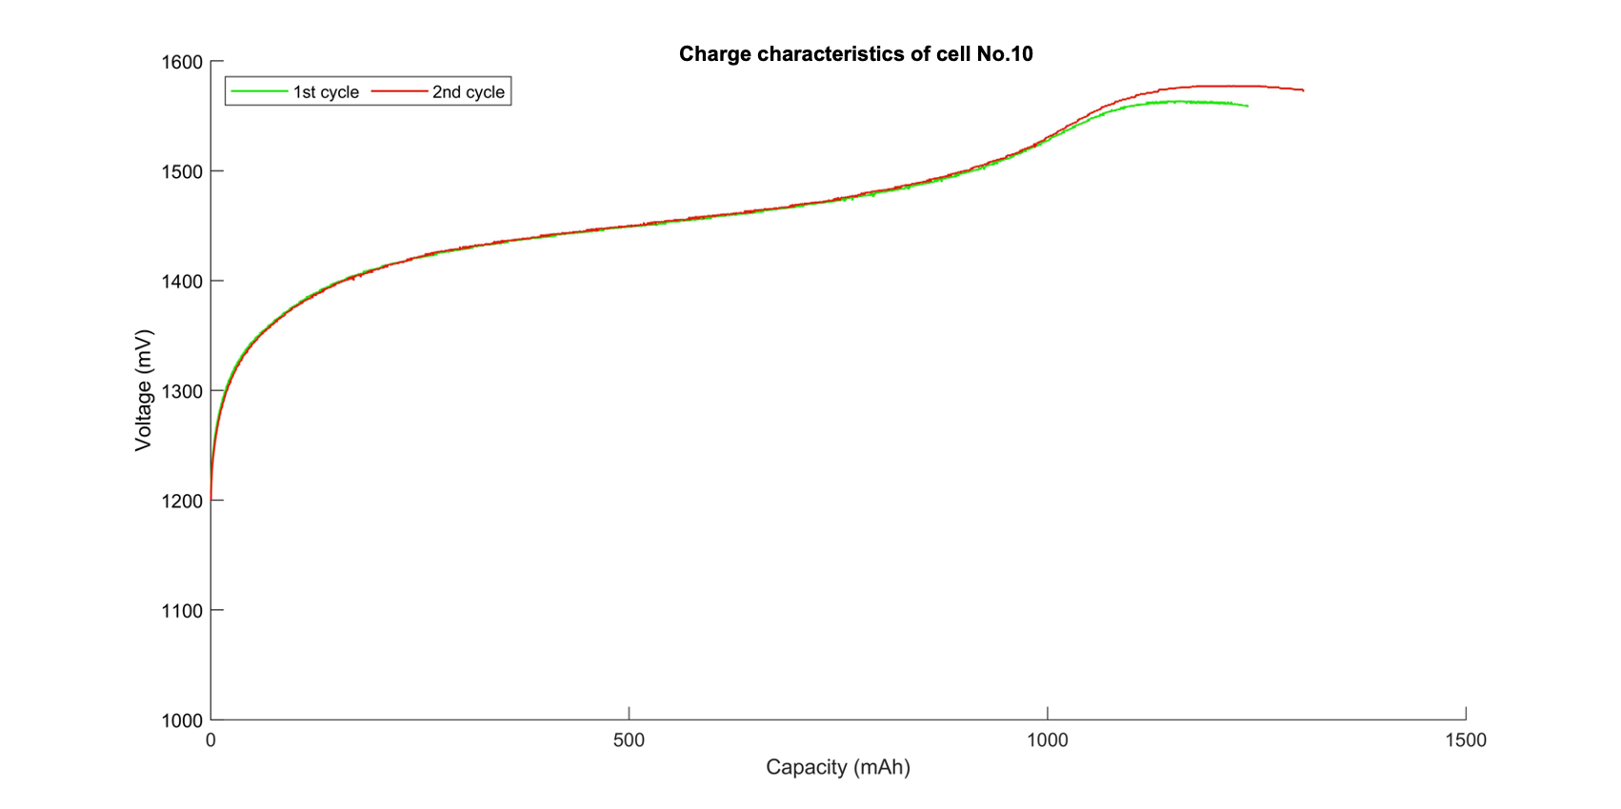



Figure 5.2-3 Function test result

Note: The 1st cycle refers to the characteristics before the thermal test, and the 2nd cycle refers to the characteristics after the thermal test.

Table 5.2-1 Measurement Result of Function Test before and after thermal test

|  |  |  |  |  |  |  |  |  |  |  |
| --- | --- | --- | --- | --- | --- | --- | --- | --- | --- | --- |
| Battery No | Mass  [g] | | | OCV  [V] | | | Capacity  [mAh] | | | Visual inspection |
| Before | After | [%] Change (<0.1) | Before | After | [%] Change (<0.1) | Before | After | [%] Change (< 5) | Pass or fault |
| #10 | 24.449 | 24.425 | 0.098 | 1.344 | 1.343 | 0.074 | 1264 | 1239.2 | 1.962 | Pass |

# Selected Batteries

Based on the selection procedure, impedance check is carried out to verify that impedance of each battery (cells) is similar as possible before assembly of the battery box. Table 6-1 shows packaging through selection procedure. One set of battery has been selected for flight module as SET-A for DRAGONFLY and the other SET-B has been kept as spare. The assembled battery cells were chosen so that the requirement of having the change of mass and open circuit voltage less than 0.1%, and the change of capacity less than 5% before and after each environment test was met. We also checked the appearance of the cells before and after the environmental test and confirmed that there was no change in the appearance by the environmental test. Battery cells used in our satellites are well tolerated over the required temperature range.

**Table 6-1 Package of cells after the Vibration Test**

|  |  |  |  |  |  |
| --- | --- | --- | --- | --- | --- |
| **FM SET** | | | | | |
|  | Cell # | OCV [V] | Mass [g] | Capacity [mAh] | Impedance [mΩ] |
|
|
| Series 1 | 4 | 1.342 | 24.65 | 1258 | 83.30 |
| 22 | 1.363 | 24.105 | 1180 | 85.20 |
| 8 | 1.341 | 24.988 | 1309 | 86.20 |
| Series 2 | 17 | 1.345 | 24.803 | 1283 | 90.00 |
| 19 | 1.346 | 24.451 | 1238 | 90.80 |
| 23 | 1.347 | 25.126 | 1323 | 93.60 |

# Battery self-discharge measurement

Self-discharge is an inherent feature of batteries. It occurs in batteries due to various reasons. Here the batteries are placed at room temperature while inside the satellites. This measurement was performed on the battery built into the satellite after the satellite's environmental test.

Access Port

|  |  |  |
| --- | --- | --- |
| **Schematic** |   **FAB Board Unassembled** |   **Assembled Satellite** |

**Figure 7-1 Test Configuration for Self-discharge measurement**

**Table 7-1: Self-Discharge Measurements Before and After Vibration Test**

|  |  |  |  |  |  |  |  |  |
| --- | --- | --- | --- | --- | --- | --- | --- | --- |
| **Before Vibration** | | | | **After Vibration** | | | | |
| **Date** | **Time (hours)** | **Voltage (V)** | **Capacity (mAh)** | Date | Time (hours) | Voltage (V) | Capacity (mAh) |
| 3/9/2024 | 0:00 | 4.187 | 3395 | 3/16/2024 | 12:00 | 4.158 | 3393 |
| 6:00 | 4.136 | 3392 | 18:00 | 4.128 | 3392 |
| 12:00 | 4.117 | 3392 | 3/17/2024 | 0:00 | 4.109 | 3392 |
| 18:00 | 4.101 | 3391 | 6:00 | 4.094 | 3391 |
| 3/10/2024 | 0:00 | 4.090 | 3391 | 12:00 | 4.082 | 3391 |
| 6:00 | 4.080 | 3390 | 18:00 | 4.074 | 3390 |
| 12:00 | 4.073 | 3389 | 3/18/2024 | 0:00 | 4.066 | 3389 |
| 18:00 | 4.066 | 3389 | 6:00 | 4.059 | 3388 |
| 3/11/2024 | 0:00 | 4.060 | 3388 | 12:00 | 4.053 | 3388 |
| 6:00 | 4.055 | 3388 | 18:00 | 4.048 | 3387 |
| 12:00 | 4.050 | 3387 | 3/19/2024 | 0:00 | 4.043 | 3387 |
| 18:00 | 4.046 | 3387 | 6:00 | 4.039 | 3386 |
| 3/12/2024 | 0:00 | 4.041 | 3386 | 12:00 | 4.035 | 3385 |
| 6:00 | 4.037 | 3385 | 18:00 | 4.032 | 3385 |
| 12:00 | 4.033 | 3385 | 3/20/2024 | 0:00 | 4.028 | 3383 |
| 18:00 | 4.031 | 3384 | 6:00 | 4.024 | 3383 |
| 3/13/2024 | 0:00 | 4.027 | 3383 | 12:00 | 4.022 | 3382 |
| 6:00 | 4.023 | 3383 | 18:00 | 4.019 | 3382 |
| 12:00 | 4.021 | 3382 | 3/20/2024 | 0:00 | 4.016 | 3381 |
| 18:00 | 4.018 | 3382 | 6:00 | 4.013 | 3380 |
|  | Percentage self-discharge in 5 days | 4.036% | 0.397% |  | Percentage of self-discharge in 5 days | 3.487% | 0.370% |
|  | Percentage self-discharge per day | 0.807% | 0.079% |  | Percentage of self-discharge per day | 0.697% | 0.074% |

Since the total capacity of the battery is measured 3395mAh by full charging up to 4.187V and discharging up to 3.1V of the battery pack. The self-discharge test was conducted for 5 days in the interval of 6 hours the battery voltage was measured from battery monitoring port. Based on the result, the battery pack of the satellites has self-discharged for 5 days before vibration is 0.079% and after vibration is 0.074% mAh per day from the measured capacity. The self-discharge results before and after the vibration test are almost the same. There is no abnormality with the assembled battery inside the satellite after the launch environment testing.

# Conclusion

The result of the battery verification test conforms to the requirement.